MAHARASHTRA UNIVERSITY OF HEALTH SCIENCE,NASHIK


NAME OF COURSE | MASTER OF SURGERY
NAME OF SUBJECT | OBSTETRICS AND GYNECOLOGY
ACADEMIC YEAR | 2021-2024

TOPIC
“STUDY OF MODIFIED MENSTRUAL CUP USE FOR EARLY
DIAGNOSIS OF POST PARTUM HAEMORRHAGE- AN

OBSERVATIONAL STUDY”

INDEX

Sr. No | Content | Page No
1 | INTRODUCTION | 1-3
2 | AIMS AND OBJECTIVES | 4
3 | REVIEW OF LITERATURE | 5-43
4 | MATERIALS AND METHODS | 44-46
5 | RESULTS AND OBSERVATION | 46-60
6 | DISCUSSION | 61-68
7 | SUMMARY | 69-70
8 | CONCLUSION | 71
9 | REFERENCES | 72-87
10 | PROFORMA | 88-90
11 | INFORMD CONSET FORM | 91-93
12 | MASTERCHART | 94

LIST OF TABLES

Sr. No. | Tables | Page No.
1 | Recommendation status of the individual components for  AMTSL | 23
2 | Classification of hemorrhage as per American college of surgeons | 24
3 | Degrees of shock after blood loss | 29
4 | Goals of resuscitation | 32
5 | Oxytocic | 33
6 | Total participants involved in study groups | 47
7 | Response before Pre placement acceptance | 48
8 | Response after Post placement acceptance | 49
9 | Complaints occurred | 50
10 | Questionnaire based on obstetrician related | 51
11 | patient related parameter | 53
12 | Mechanical compression device | 56
13 | Reduction in invasive procedure | 57
14 | Intensive Care Unit management | 58
15 | Reduction in hospital stay due to morbidity from postpartum haemorrhage | 59
16 | Reduction in maternal morbidity attributable to PPH | 60

LIST OF GRAPHS
Sr. No. | Graphs | Page No.
1. | Graph according to total participants involved in study groups | 47
2. | Graph according to Response before Pre placement acceptance | 48
3. | Graph according to post placement acceptance | 49
4. | Graph according to Complaints occurred | 51
5. | Graph according to Questionnaire based on obstetrician related | 52
6. | Graph according to patient related parameter | 54
7. | Graph according to Mechanical compression device | 56
8. | Graph according to reduction in invasive surgical intervention | 57
9. | Graph according to Intensive Care Unit management | 58
10. | Graph according to Reduction in hospital stay due to morbidity from post-partum haemorrhage | 59
11. | Graph according to Reduction in maternal morbidity attributable to PPH | 60

LIST OF FIGURES
SR. No. | Figures | Page No
1 | Blood supply of pelvis | 5
2 | Utero-ovarian blood supply | 7
3 | Collateral circulation | 8
4 | Schultze method and Matthew Duncan method | 13
5 | Crisscross pattern of muscles and blood vessels in Uterus | 14
6 | Estimation of blood loss | 25
7 | Brass V drape | 26
8 | Modified early obstetric warning system chart | 28
9 | ANTISHOCK GARMENT | 35
10 | SR Cannula | 36
11 | FIGO recommendations for management of PPH | 36
12 | WHO recommendations for PPH treatment | 37
13 | Bimanual Uterine Compression | 38
14 | PPH Cup | 40
15 | Working Model of PPH Cup | 42

ABBREVIATIONS

Abbreviations | Full Form
PPH | Postpartum haemorrhage
WHO | World Health Organisation
SRS | Sample registration scheme
ICMR | Indian Council of Medical Research
DIC | Disseminated Intravascular Coagulation
AMTSL | Active Management of the Third Stage of Labor
PGF2α | Prostaglandin F2 alpha
BRASSS-V | Blood Recovery and Assessment System for Surgical  Settings - Version V
ICU | Intensive Care Unit

INTRODUCTION

Though labour is a physiological process, it is often associated with morbidity and mortality. The most common cause being post partum haemorrhage.¹ Life threatening obstetric hemorrhage occurs in approximately 1 per 1000 deliveries.
The most recent Practice Bulletin from the American College of Obstetrics and Gynecology places the estimate at 1,40,000 maternal deaths per year or 1 woman every 4 minutes.
Postpartum haemorrhage (PPH) remains a leading cause of maternal mortality, especially in developing countries.² It is a complication following delivery and the most common cause of maternal death, accounting for about 35% of all maternal deaths worldwide. These deaths have a major impact on the lives and health of the families affected. PPH is commonly defined as a blood loss of 500 ml or more within 24 hours after birth, while severe PPH is defined as a blood loss of 1000 ml or more within the same timeframe according to World Health Organisation (WHO). A small blood loss that makes the woman haemodynamically unstable is also termed as PPH. PPH is a major cause of morbidity and mortality with in the first 24 hours following delivery and this is regarded as primary PPH; whereas any excessive bleeding from the birth canal occurring between 24 hours and 12 weeks postnatally (after delivery) is termed as
secondary PPH.³
In India, sample registration scheme (SRS), during survey of causes of death 1998, reported that PPH was a major cause of maternal mortality and responsible for 30 % of maternal deaths and according to SRS 2001-2003, PPH accounts 38 percent of maternal deaths. Estimates of maternal mortality ratio in India done by Indian Council of Medical
Research (ICMR) in 2003 also showed PPH as a leading cause of maternal mortality in study population. Incidence of PPH is reported as 2% - 4% after vaginal delivery and 6% after caesarean section; with uterine atony being the cause in about 50% cases. Every year
about 14 million women around the world suffer from PPH.³
Because of the difficulty of randomised trials in women presenting with PPH, the use of tranexamic acid for preventing PPH in high-risk women could be regarded as a proxy for assessing its use for treating PPH.⁴ In particular, high-risk factors which may not be responsive to uterotonics, such as placenta praevia and lacerations from instrumental delivery, may respond to tranexamic acid. If tranexamic acid is found to be effective in the prevention of PPH in such high- risk women, its use could be extrapolated to the treatment of PPH (as has been the case for most treatments for PPH, such as oxytocin and ergometrine). The changes in the fibrinolytic components during and immediately after placental delivery are consistent with fibrinolysis occurring as a response to local fibrin deposition. The plasma fibrinogen level decreases during the 3rd stage of labour and after placental delivery, and the level of fibrin/ fibrinogen degradation products in the serum increases 1 hour after childbirth and remains raised in the early puerperium raised in the early puerperium. ⁵
Early detection and treatment of PPH is critical to reducing morbidity and mortality, yet diagnosis can be challenging, especially in low-resource settings. Visual estimation of blood loss is subjective and often underestimates the true volume. ₆ Quantitative measurement methods like weighing blood-soaked materials are not accurate and often subjective. ⁷ There is a clear need for an affordable,accurate and easy-to-use tool to objectively monitor postpartum blood loss and enable early diagnosis of PPH.
Menstrual cups are reusable, bell-shaped devices made of flexible medical-grade silicone or rubber that are inserted into the vagina during menstruation to collect blood. ⁸ They have gained popularity as an eco-friendly and cost-effective alternative to disposable pads and tampons. Remarkably, menstrual cups may have utility beyond their original purpose with some modifications, they could potentially be adapted for postpartum use to detect excessive bleeding. By quantifying the volume of blood collected, a modified menstrual cup/Archit cup could provide an objective measure of postpartum blood loss to aid in early PPH diagnosis.
To date, no studies have evaluated the use of menstrual cups for postpartum blood monitoring. However, some research has been done on the use of other blood collection devices for this purpose. A recent cluster-randomized trial found that use of a calibrated blood collection drape significantly improved detection of PPH compared to standard visual estimation. ⁹ This suggests that quantitative measurement of postpartum blood loss is feasible and can enhance diagnosis.Modified Menstrual cups, with their ability in accurately measuring blood loss is such a great innovation for managing post partum haemorrhage in Golden hour. This study aims to begin addressing these knowledge gaps by evaluating the feasibility and acceptability of using modified menstrual cups for early detection of postpartum hemorrhage in a low-resource setting. Hence the findings could inform the development of an innovative, low-cost tool to improve maternal health outcomes.

AIMS AND OBJECTIVES
Aim of study:
To assess the modified menstrual cup/Archit cup, use for early diagnosis of post-partum haemorrhage.
Objectives of the study:
- To estimate real time and accurate amount of blood loss and early management of patient undergoing PPH in golden hour.
- To estimate frequency of postpartum haemorrhage in real time.
- To study accurate amount of blood loss in post-partum Haemorrhage.
- To study maternal outcome on basis of HB level, amount of blood loss and
associated complications.

REVIEW OF LITERATURE
RELEVANT ANATOMY OF PELVIS:
BLOOD SUPPLY OF PELVIS: ¹⁰
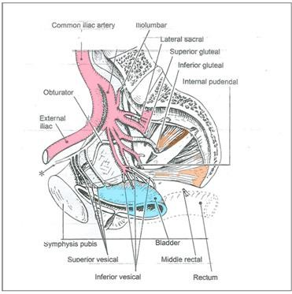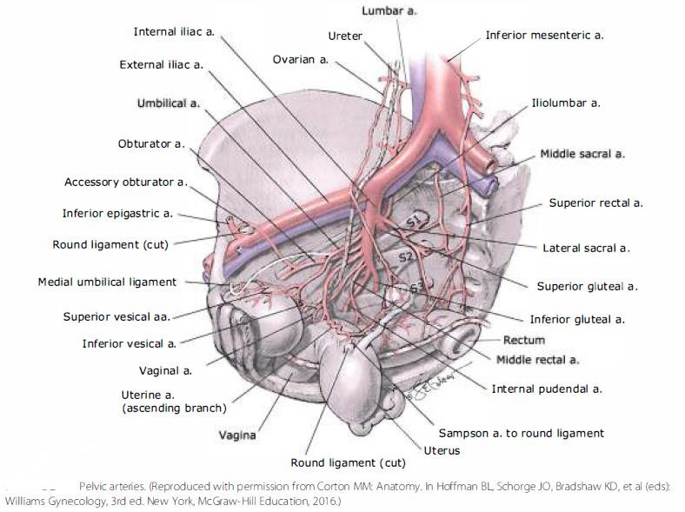

Figure 1: Blood supply of pelvis
Aorta bifurcates at the level of fourth lumbar vertebra into common iliac arteries. Common iliac artery divides into external and internal iliac artery at the level of pelvic brim at sacroiliac joint. External iliac artery gives no branch in the pelvis. Internal iliac artery goes down towards the superior margin of greater sciatic foramen and divides into anterior and posterior branch. Anterior branch runs towards the ischial spine and gives branches to supply the pelvic organs. Posterior branch passes posteriorly and gives rise to superior gluteal, iliolumbar and lateral sacral artery. Anterior division of the internal iliac artery gives branches that supply the pelvic organs, i.e. superior vesical artery, middle rectal artery, vaginal artery, obturator artery, uterine artery, internal pudendal artery, inferior gluteal artery.
Uterine artery:
The uterine artery, a main branch of the internal iliac artery enters the base of the broad ligament. The uterine artery courses medially to the lateral side of the uterus. Approximately 2 cm lateral to the cervix, the uterine artery crosses over the ureter.
Once the uterine artery has reached the supra vaginal portion of the cervix, it divides. The smaller cervico-vaginal artery supplies blood to the lower cervix and upper vagina. The main uterine artery branch runs abruptly upward and travels cephalad along the lateral margin of the uterus. Along its path, this main artery provides a branch of considerable size to the upper cervix and then numerous other medial branches serially penetrate the body of the uterus to form the arcuate arteries.
Each branch arches across the organ by coursing within the myometrium just beneath the serosal surface. Arcuate vessels from each side anastomose at the uterine midline. Radial artery branches originate at right angles from the arcuate arteries and travel inward through the myometrium, enter the endometrium/decidua, and branch there to become either basal arteries or coiled spiral arteries. The spiral arteries supply the funcrionalis layer. Also called the straight arteries, the basal arteries extend only into the basalis layer. ¹⁰
As the uterine artery courses cephalad, it gives rise to Sampson artery of the round ligament. Just before the main uterine artery vessel reaches the fallopian rube, it divides into three terminal branches. The ovarian branch of the uterine artery forms an anastomosis with the terminal branch of the ovarian artery; the tubal branch makes its way through the mesosalpinx and supplies part of the fallopian tube; and the fundal branch penetrates the uppermost uterus.
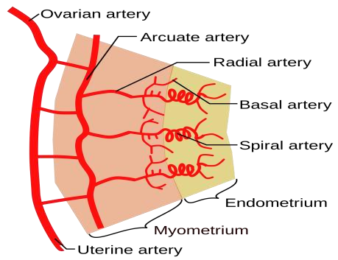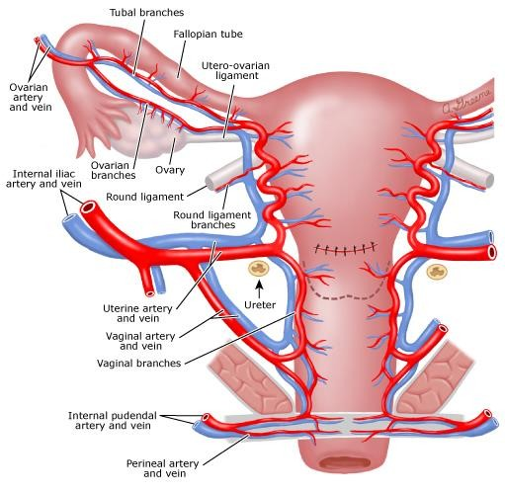
Figure 2: Utero-ovarian blood supply

Ovarian artery:
In addition to the uterine artery, the uterus receives blood supply from the ovarian artery. This artery is a direct branch of the aorta and enters the broad ligament through the infundibulopelvic ligament. At the ovarian hilum, it divides into smaller branches that enter the ovary. As the ovarian artery runs along the hilum, it also sends several branches through the mesosalpinx to supply the fallopian rubes. Its main stem, however, traverses the entire length of the broad ligament toward the uterine cornu. Here, it forms an anastomosis with the ovarian branch of the uterine artery. This dual uterine blood supply creates a vascular reserve to prevent uterine ischemia if ligation of the uterine or internal iliac artery is performed to control postpartum hemorrhage.

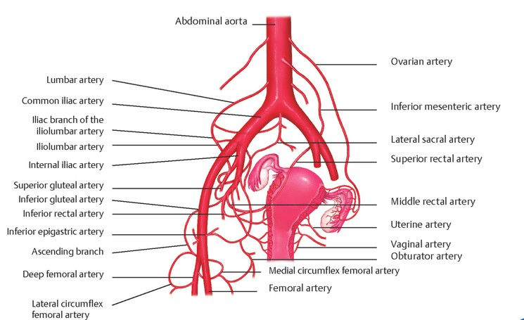

Figure 3: Collateral circulation

Collateral Circulation:
- Middle rectal artery and the superior rectal artery(inferior mesenteric)
- The iliolumbar artery with the last lumbar artery(aorta)
- The lateral sacral arteries with median sacral artery(aorta)
- The uterine artery and ovarian artery(aorta)
- The obturator artery and the Inferior epigastric artey (external iliac)
- The superior gluteal and Lateral circumflex femoral (femoral)
- The superior gluteal and deep circumflex iliac (external iliac)
- The inferior gluteal and medial circumflex femoral (femoral)
The anatomy and blood supply of the pelvis is important in cases of postpartum haemmorrhage

INTRODUCTION TO PPH:
Mumtaz Mahal, wife of Shahjahan died in 1631 during the birth of her 14th child secondary to PPH Shah Jahan had the Taj Mahal built as a tomb for her, which is considered to be a monument of undying love.
Millennium development goal 5 (MDG 5) has two important targets to achieve to improvise maternal health.
- To reduce the maternal mortality ratio by 75%
- To achieve universal access to reproductive health.
Once the above target is achieved, next target will be to reduce the maternal mortality ratio (MMR) to less than 70/lac live births by year 2030 in accordance to target 3.1 in sustainable development goal 3.2. If it can be achieved, we will be able to prevent the maternal deaths due to preventable causes.
Postpartum hemorrhage (PPH) is a major contributor of maternal mortality and morbidity around the world, particularly in developing countries. Although the maternal mortality has been reduced by 45% from 1990 to 2013 (380 to 210 maternal deaths per 1 lac live births) but figures are still high. It has been noted that in 2013 around 2.89 lac maternal deaths occurred amounting to 800 women dying daily of pregnancy-related complications.⁶
India has achieved ground breaking success in achieving the reduction in MMR by 77%. With continued improvement in maternal health the MMR has reduced
from 556/1 lac live births in 1990 to 130/1 lac live births in 2016.⁶ This has put India on track to achieve the target rate of 70/1 lac live births by 2030.
The main reason behind this success is the institutional deliveries, various maternal programs, increased literacy and public-private partnership. There is significant disparity of maternal mortality amongst different states in India, i.e. maternal mortality is highest in Assam (237/1 lac live births) and lowest in Kerala (46/1 lac live births).⁷
Definition of PPH
There are at least 10 near misses with each maternal death due to PPH.PPH is also associated with severe maternal morbidity due to significant blood loss leading to shock, organ dysfunction, multiple blood transfusions and peripartum hysterectomy. PPH is conventionally defined in relation to amount of blood loss and mode of delivery within 24 hours of postpartum period, thereby defining early or primary PPH. However, late or secondary PPH is defined as hemorrhage occurring later than 24 hours and till 12 weeks.
PPH has been defined in various ways. WHO definition of PPH in 2012clearly states that PPH is blood loss more than 500 mL in vaginal delivery and more than 1000 mL
in cesarean section.^{8,9 Whenever} blood loss is more than 1000 mL in vaginal delivery, it is termed as severe PPH. Another clinical definition of PPH defines it by more than 15% of total blood loss or fall in hemoglobin levels by 10% in postpartum period.
INTERNATIONAL GUIDELINES REGARDING THE DIAGNOSIS OF PPH
International Federation of Gynecology & Obstetrics (2012):¹⁰ States that blood loss of more than 500 mL in vaginal delivery and 1000 mL in cesarean section or any amount of blood loss which produce hemodynamic instability is diagnostic of PPH. It also mentions that the clinical estimates of blood loss are mostly unreliable.
American College of Obstetrics & Gynecologist (2017):¹¹ Diagnosis of PPH should be made once blood loss is more than 1000 mL regardless of route of delivery. Moreover, it is important to note that signs and symptoms appear only when blood loss is substantial which requires a thorough evaluation.
Royal College of Obstetricians Gynecologists (2016):¹² PPH is minor if blood loss is between 500 mL and 1000 mL & major if blood loss is more than 1000mL. It also states that hemodynamic changes like tachycardia, tachypnea, and fall in blood pressure appear when the blood loss is between 1000mL and 1500mL. Systolic BP less than 80 mm Hg indicates blood loss of more than 1500mL. Blood loss more than 40% of total blood volume is life threatening.

Pit falls of the definitions
Healthy women do not have signs of hemodynamic instability unless blood loss is
above one litre.^{15, 16}
Visual estimation of blood loss is not definitive and usually underestimates, thus delaying the diagnosis and management.
Thus, keeping in mind the above factors, simple, easy and relevant clinical index has been coined known as "shock index" (SI) which is calculated by dividing heart rate (HR) by systolic blood pressure (SP).^{17,18}IfHR is more than SBP i.e. SI more than 0.9, the postpartum women will need immediate attention or requirement of transfusion.
Retrospective analysis of 958 women with hypovolemic shock as a result of obstetric hemorrhage showed SI to be good predictor of maternal mortality and morbidity
compared with vitalsigns.^{17, 18}
PATHOPHYSIOLOGY OF POST PARTUM HAEMORRHAGE
The mechanism of postpartum hemostasis involves a highly complex and coordinated interplay of mechanical and hormonal factors. In the last trimester of pregnancy, the utero-placental circulation receives approximately one-fifth of maternal cardiac output, or 1000 mL/min. This immense blood flow implies that postpartum hemorrhage (PPH) can lead to maternal exsanguination within a short time.¹⁹The entire duration of pregnancy is characterized by a state of hypercoagulability. There is an increase in the total platelet count and coagulation factors, especially fibrinogen, factor VII, factor VIII, factor IX, factorXII and WF. Additionally, there is shortening of activated partial thromboplastin time (aPTT) by 4 seconds. These changes are crucial in hastening the process of clotting and achieving hemostasis.²⁰During the third stage of labor, normal placental separation occurs along a physiological plane of cleavage which is formed by vascular networks between the basal plate and uterine wall. This is followed by expulsion of the placenta and myometrial contraction and retraction which ultimately leads to cessation of postpartum bleeding.
PLACENTAL SEPARATION
The mechanical events leading to delivery of placenta and its membranes initiate in the second stage of labor with detachment of placental membranes. With the delivery of baby, the myometrial fibers undergo powerful contraction and shorten by retraction, which results in reduced uterine size and volume. This leads to a decrease in placental site surface area and as the placenta is an inelastic structure, it results in compression and shearing off of the placenta.²⁰ Literature describes two methods of placental separation during third stage of labor resulting in different bleeding patterns:
- Schultze method
- Matthew Duncan method
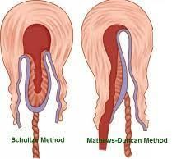

Figure 4: Schultze method and Matthew Duncan method

ARREST OF POSTPARTUM BLEEDING
The uterine myometrium is composed of smooth muscles that are joined by connective tissue with multiple elastic fibers. These muscle fibers are arranged in a crisscross pattern of lattice-work through which pass the blood vessels supplying the placental bed. This ensures that with sustained contraction of the myometrial muscle fibers, there is constriction of blood vessels thereby obliterating their lumen which achieves hemostasis. It is for this specific attribute that the myometrial fibers are referred to as the 'living ligatures' or 'physiological sutures' of the uterus
Various endocrine mechanisms and factors such as oxytocin and prostaglandins secreted by placenta, deciduas and fetal membranes have been implicated in the initiation of myometrial contraction. After the initial hemostatic mechanisms, permanent changes ensue within the lumen of blood vessels induced by local and systemic clotting factors which result in obliteration of the lumen of blood vessels.
Variations in the physiological cascade result in PPH.^{20, 21}
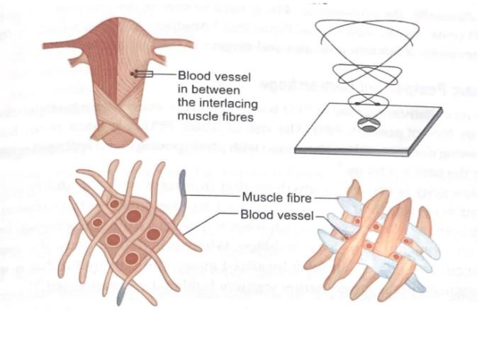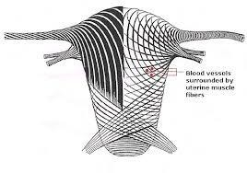

Figure 5: Crisscross pattern of muscles and blood vessels in Uterus PATHOGENESIS OF PRIMARY POSTPARTUM HEMORRHAGE
The main causes of PPH are uterine atonicity, genital tract trauma and retained placental tissue. Other rarer causes can be due to coagulation abnormalities, uterine inversion or morbid adherence of placenta. The pneumonic 4Ts is used to denote the different causes of PPH – Tone Tissue Trauma and Thrombin. Another T is also added for the importance of operation theatre and surgery in the management of PPH.
ATONIC POSTPARTUM HAEMMORRHAGE
The most common cause of PPH is due to uterine atony which is responsible for 8085% of primary PPH. The risk of atonic PPH is greatest in the hour following delivery, Atonicity is caused by anything that interferes with the ability of the uterus to contract and retract. The relaxed myometrial fibers fail to constrict the traversing blood vessels which leads to bleeding from the placental bed. Uterine atonicity can be focal or diffuse. In diffuse atony, the uterus is flaccid and dilated, in focal localized atony, the uterine fundus is well contracted and the lower uterine segment is dilated and
ballooned.22, 23
Predisposing Factors
- Grand multiparity
- Overdistended uterus (multiple pregnancy, hydramnios, macrosomia)
- Atonic PPH in previous pregnancies
- Antepartum hemorrhage
- Induced or augmented labor
- Chorioamnionitis.
- Uterine abnormalities
- Drugs: Tocolytic drugs, such as glyceryl trinitrate, terbutaline and deep general anesthesia (especially fluorinated hydrocarbons).
Traumatic Postpartum Hemorrhage
Genital tract injuries comprise about 10-15% of all primary PPH. They can result from lacerations of cervix, vagina, perineum, colporrhexis and rupture uterus. The traumatic injuries may occur due to the natural processes of delivery or may be related to manipulations/instrumental delivery. During cesarean section, lateral extension of uterine incision, vascular injuries to uterine artery or broad ligament may also lead to
PPH. This is common with second stage cesarean sections or obstructed labor.^{23, 24}
Coagulopathy
Clotting abnormalities may be due to inherited or acquired bleeding diathesis. They are a relatively rare cause of hemorrhage (around 3% of PPH). Acquired coagulation defects may be seen in association with abruption placenta, amniotic fluid embolism, severe pre-eclampsia, eclampsia and sepsis. They may present as hypofibrinogenemia, thrombocytopenia and disseminated intravascular coagulation (DIC). Besides, DIC can also complicate hemorrhage due to any other cause.²⁵
RETAINED PLACENTAL TISSUE
Failure of the uterus to contract may be associated with retained placenta or placental fragments. Presence of retained material in the uterine cavity acts as a physical block against uterine contraction which is needed to constrict placental bed vessels.

PLACENTA PREVIA
Placenta is implanted in the lower uterine segment where the musculature is inadequate to initiate the process of contraction and retraction.²⁶Furthermore, a higher incidence of giant cell infiltration into trophoblasts is seen in women with placenta previa, the significance of which in relation to PPH is being studied.²⁷
MORBID ADHERENCE OF PLACENTA
Placenta accreta spectrum is a leading cause of maternal morbidity and mortality. It carries a significant risk of major obstetric hemorrhage, invariably requiring emergency cesarean hysterectomy. Majority of women require massive blood transfusion, defined as 8 units or more and are at a high risk for transfusion-related complications such as thrombocytopenia, coagulation abnormalities, multiorgan failure and maternal death.²⁹

SECONDARY POSTPARTUM HEMORRHAGE
It is defined as abnormal bleeding from the genital tract between 24 hours and 12 weeks postpartum. It is much less common than primary PPH, occurring in about 1% of
deliveries.³⁰
PREVENTION OF PPH
The fact that deaths due to PPH in the developed world are much less implies that these are definitely preventable. Comprehensive Emergency Obstetric Care (Government of India Initiative) has shown 33%reduction in maternal deaths and AMTSL is an important component. AMTSL reduces the occurrence of severe PPH by approximately
60-70%.
ACTIVE MANAGEMENT OF THIRD STAGE OF LABOUR
AMTSL is a prophylactic and effective intervention to initiate effective uterine contractions and facilitate smooth placental expulsion as a measure for the prevention of atonic PPH
The components of active management are:
- THE USE OF UTERTONIC AGENTS
  - The use of uterotonic agents is recommended for all births
- OXYTOCIN
  - Oxytocin is the primary drug of choice in the third stage of labor. It is a nonapeptide produced in the hypothalamus. It acts on the smooth muscle of uterus increasing the amplitude and frequency of contractions.
It has a plasma half-life of 1-6 minutes with approximately 8-20 minutes of duration of action. Oxytocin should be stored between 2 and 8°C.
It is administered as 10 IU intramuscularly to the mother immediately after the delivery of anterior shoulder of baby. Intravenous route is preferred during cesarean section.5
IU oxytocin diluted to 5 mL can be given intravenously over 1-2 minutes. Administration through umbilical vein after clamping of cord has also been tried to accelerate the placental separation and to decrease the amount of blood loss.⁴⁰
Side effects: minimal side effects like nausea, vomiting. Rapid intravenous bolus can cause hypotension and tachycardia. Antidiuretic effect with hyponatremia is usually observed with higher dosage (30-50 ml/min). Hypersensitivity to oxytocin is the contraindication for its usage.
Recent Cochrane reviews found that oxytocin and ergometrine were preferable to intramuscular prostaglandins like carboprost or misoprostol for routine prophylaxis for prevention of PPH.⁴³
According to WHO guidelines Oxytocin (10 IU, IV/IM) is the recommended uterotonic drug for the prevention of PPH.³² Oxytocin (IV or IM) is the recommended uterotonic drug for the prevention of PPH in caesarean section.³²
Ergot Alkaloids
Ergometrine is derived from naturally occurring substance ergot, an alkaloid containing product of fungus claviceps purpurea. Methyl ergometrine is a semisynthetic drug derived from lysergic acid. They are nonselective 5 hydroxy-tryptamine 1 agonists and have affinities for noradrenaline and dopamine receptors. Onset of action is within 1-5 minutes and half-life is 30 minutes to 2 hours. It is detoxified in the liver and eliminated through kidneys in urine. It has to be stored at 2-8°C.
Dosage: Ergometrine 0.25 mg, methyl ergometrine 0.2 mg.
It can be used intramuscularly for active management of third stage.
Side effects include nausea, vomiting, rise in blood pressure, myocardial infarction.
It is contraindicated in cardiac patients, severe pre-eclampsia and eclampsia, Rhnegative women. Though a very effective uterotonic agent, there is not much supportive evidence for its use as a single agent.
According to WHO guidelines in settings where oxytocin is unavailable the use of other injectable uterotonics -ergometrine/methyl ergometrine is recommended.³²
FOGSI recommends use of Methyl ergometrine 0.2 mg intramuscular if oxytocin is not available.⁴⁴
Syntometrine
It contains 5 IU oxytocin and 0.5 mg ergometrine. It is used by intramuscular route.
Onset of action is two and a half minute and duration of action lasts for around 3 hours. A Cochrane database systematic review although found it more effective than oxytocin, its side effects like hypertension, nausea, vomiting limit its usage.
Ergometrine–oxytocin may be used in the absence of hypertension in women at increased risk of haemorrhage as it reduces the risk of minor PPH.
Misoprostol
It is prostaglandin El analog with potent uterotonic action. It is available in tablet form. It is easily available, cheap, stable at room temperature, long shelf life, less side effects. It can be administrated by oral, sublingual, vaginal and rectal route.
Side effects include fever, chills, shivering, nausea, vomiting, transient diarrhea. It is safe in asthma and heart disease.
Government of India guidelines (2013) recommend 600 Mg misoprostol orally after delivery for prevention of PPH. FOGSI guidelines (2012) recommend 600 ug misoprostol orally, sublingually or rectally for prophylaxis of PPH. Hernández-Castro F et al found that additional use of buccal misoprostol in conjunction with AMTSL
reduced the need for additional uterotonic drugs.⁴⁷

Carboprost
Carboprost is a synthetic prostaglandin analogue of PGF2α, 250 mcg IM Onset: 1-2 mins
Lasts 15-20 mins .Vomiting, diarrhea, bronchospasm. Avoid in bronchial asthma.⁴⁴ Requires special storage conditions: 2-8°C.
According to recent WHO guidelines carboprost 0.25 mg by intramuscular injection repeated at intervals of not less than 15 minutes to a maximum of eight doses (use with caution in women with asthma)
Carbetocin
Carbetocin is a synthetic oxytocin analogue that binds to the same myometrium receptors as oxytocin with similar affinity. Long-acting synthetic nonapeptide analogue of oxytocin with agonist properties. Plasma half-life: 40 min (4-10 times longer than oxytocin)
o Onset of contraction of uterus: 2 min o Duration of action after single intravenous injection of Carbetocin: 1 hour o A statistically significant reduction in the need for further uterotonics compared with oxytocin for those undergoing a caesarean, but not for vaginal delivery.⁴⁸No statistically significant differences between carbetocin and oxytocin in terms of risk of PPH.⁴⁸ o The use of Carbetocin (100 µg, IM/IV) is recommended for the
prevention of PPH for all births in contexts where its cost is comparable
to other effective uterotonics. Vaginal birth or caesarean section For PPH prevention only.³²
TRANEXEMIC ACID:
TXA is a competitive inhibitor of plasminogen activation and can reduce bleeding by inhibiting the breakdown of fibrinogen and fibrin clots ..
The World Health Organization (WHO) recommends early use of intravenous tranexamic acid (TXA) within 3 hours of birth in addition to standard care for women with clinically diagnosed postpartum haemorrhage (PPH) following vaginal birth or caesarean section. • Administration of TXA should be considered as part of the standard PPH treatment package and be administered as soon as possible after onset of bleeding and within 3 hours of birth. TXA for PPH treatment should not be initiated more than 3 hours after birth. • TXA should be used in all cases of PPH, regardless of whether the bleeding is due to genital tract trauma or other causes. • TXA should be administered at a fixed dose of 1 g in 10 mL (100 mg/mL) IV at 1 mL per minute (i.e., administered over 10 minutes), with a second dose of 1 g IV if bleeding continues after30 minutes. • TXA should be administered via an IV route only for treatment of PPH. Research on other routes of TXA administration is a priority.
Controlled Cord traction
Delivery of placenta by controlled cord traction method was recommended in active management in 2007 WHO guidelines. In 2012, WHO updated guidelines, it was described as an option in the third stage active management.³²
Cord traction is the recommended method for removal of the placenta in cesarean section.³²A meta-analysis in 2015 showed that by using controlled cord traction method the mean blood loss, mean duration of third stage, and risk of blood loss were all decreased.³⁹
CORD CLAMPING
Delayed cord clamping (performed approximately 1 to 3 minutes after birth) is recommended for all births while initiating simultaneous essential newborn care.³² Early cord clamping (<1 minute after birth) is not recommended unless the neonate is asphyxiated / needs to be moved immediately for resuscitation/other obstetrics indication.²
Uterine massage
After the delivery of the placenta, uterine tone should be immediately assessed to ensure a contracted uterus; continue to check after every 15 minutes for 2 hours. This method has been recommended for routine use in the refocused WHO guidelines in 2012.³² A study by Chen et al. on 2340 pregnancies, showed that the addition of fundal massage to oxytocin did not decrease PPH. (16) But routine and frequent uterine tone assessment remains a crucial part of immediate postpartum care, particularly for the optimization of early PPH diagnosis.³²
Table 1: Recommendation status of the individual components for AMTSL by

provider⁷⁴
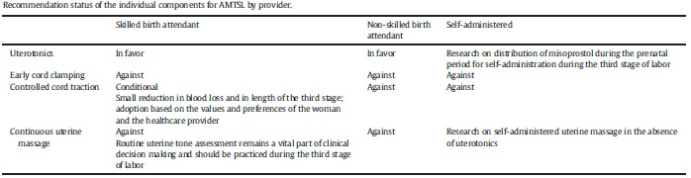
MEASUREMENT OF BLOOD LOSS
For management of PPH, prediction of PPH based on risk and assessment of blood loss during third stage of labor is vital. Inaccurate assessment of peripartum blood loss leads to delay in the management and adverse outcomes like hypovolemic shock and death. Over estimation can lead to unnecessary transfusions and its consequences thereof.
Indirect method: In this method, we assess the consequences of blood loss on the body to indirectly assess the amount of blood loss. Changes are detected as increasing pulse rate, fall in mean blood pressure decreased urine output. The American College of Surgeons have given a classification for hemorrhagic shock.⁷⁵ Women may progress rapidly from class I to class III and IV with ongoing blood loss. The advantage of this method is that it provides an assessment of blood loss clinically on the spot so that adequate resuscitation can be commenced.

Table 2: Classification of hemorrhage as per American College of Surgeons
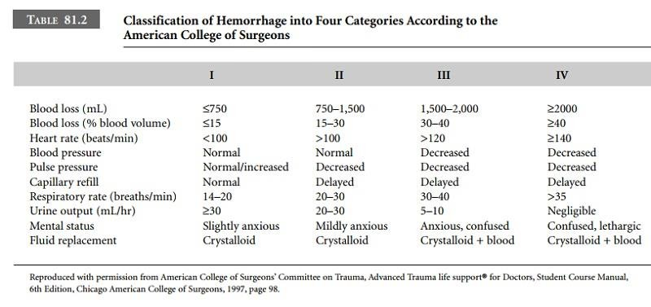
Direct methods:
Visual assessment-This is an observational method to visually assess the amount of blood loss. The assessment of blood loss is based on the number of soaked mops and amount of blood in the container below the delivery bed. It is a simple and convenient method. There are many studies which have compared visual estimation of blood loss with actual measurement at cesarean and vaginal delivery and concluded that visual estimation is inconsistent and there is likelihood of under or overestimation of blood loss.^{76,77,78,} Factors like mixing of blood with amniotic fluid, urine and other fluids are confounding factors which make visual assessment difficult.
A pictorial guide to estimated blood loss can be used for training of birth attendants.
Collection of blood in containers, bags and bed pan.
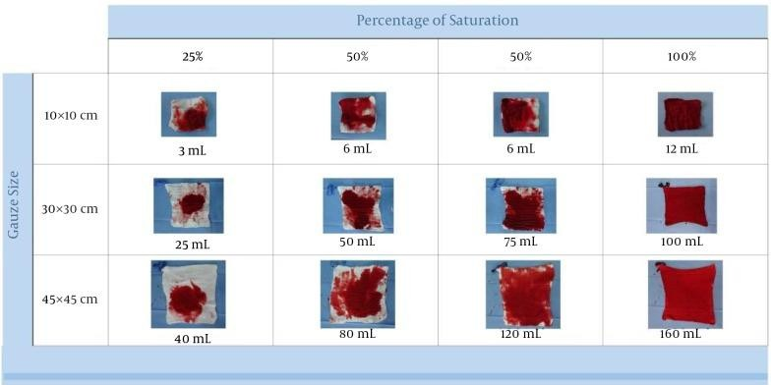

Figure 6: Estimation of blood loss
In Tanzania, they use the Kanga method. Two-soaked kangas equals 500 mL blood loss. This provides a rough estimate of blood loss depending on the number of Kangas soaked in blood.⁸⁴
Gravimetric method--This requires weighing the dry sponges, mops and drapes before delivery followed by weighing of soaked sponges after delivery to estimate blood loss.
Blood collection devices like BRASSS-V drape, It was developed by the NICHDfunded Global Network UMKC/JNMC/IC collaborative team specifically to estimate postpartum blood loss.⁸⁵Studies have shown that the blood loss estimation with this device was 33% more accurate than visual assessment⁸⁶ and it resulted in timely and earlier transfer of women to referral facility.but overall accurate measurement remains challenging .
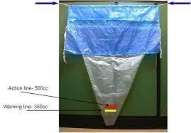

Figure 7: Brass V drape
Acid hematin method-- subjected to spectrophotometry⁹¹ or calorimetry⁹² to estimate the blood loss, it requires equipment, trained personnel which may not be available in all settings.
Plasma volume changes--Here radioactive tracer elements are used to calculate change in the plasma volume before and after delivery.
Fall in hemoglobin and hematocrit--In this, the hemoglobin and hematocrit are measured on the second day post-delivery. More than 10% fall in hematocrit from predelivery value indicates PPH. Normally after delivery, the hematocrit falls and recovers back to predelivery status within 5-7 days.
A computer-based mathematical model has been developed to evaluate blood loss in surgical procedures but it is mainly used in research settings.⁹⁴
MANAGEMENT OF PPH
PPH is one of the nightmares for an obstetrician, as by the time a patient becomes symptomatic she would have lost a significant amount of blood and can deteriorate within minutes
The deaths due to PPH has decreased due to aggressive management.^{95, 96}
The management of PPH involves early recognition, communication, resuscitation, evaluating the cause and directed treatment-all components being taken care of simultaneously. Multidisciplinary coordination with other specialties especially with blood bank is critical for optimal patient care.
Early Recognition
Of all, early detection of PPH remains the cornerstone of its management. Avoiding delays in the diagnosis and treatment will have significant impact on morbidity and mortality. Pulse rate charting, blood pressure charting, uterine palpation, urine output and assessment of bleeding per vaginum should be done every 15 minutes for the first postpartum hour. Any change in the clinical parameters should raise alarm.
MEOWS (Modified Early Obstetric Warning System) charting is of paramount
importance in high risk patients. It plays an essential role in prompt diagnosis of women who are deteriorating and therefore helps in timely intervention.^{98,99,100} On MEOWS chart if vitals are projected in one red (i.e. score of 3 in any parameter) or two amber (i.e. score of more than or equal to 4), one has to review the patient and intervene. If score is more than or equal to 6, patient should be reviewed by senior obstetrician and anesthetist and intervention should be done sooner than later.
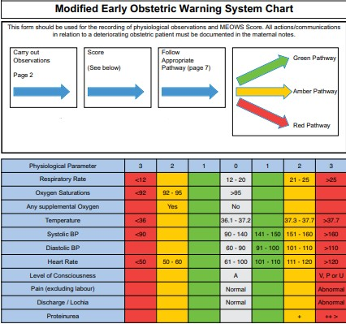

Figure 8: Modified early obstetric warning system chart

Obstetric Shock Index: Ratio of heart rate upon systolic blood pressure (SBP) is known as Obstetric Shock Index which is an early marker of hemodynamic compromise and if >1 it is indicative of massive hemorrhage.
Obstetric shock index = Heart rate/systolic blood pressure
It is better to overestimate the blood loss rather underestimating the one. Depending
upon the amount of blood loss, patient will present with different degrees of shock.^{101,}
102

Table 3: Degrees of shock after blood loss
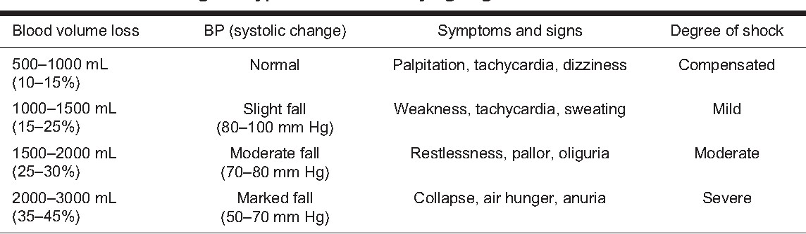

Communication:
Communicate with the patient and her attendant regarding the situation and obtain the informed written consent. Alert the supporting staff, senior obstetrician, anesthetist, hematologist, interventionist, surgeon and nursing staff. This plays a vital role as management and outcome of PPH depends on team effort

Initial Resuscitation:
Once PPH occur, the resuscitative measures must begin immediately before the patient lands up in irreversible shock. The first hour after PPH is referred as the golden hour as the aggressive management in this period is life saving and no stone should be left unturned to achieve this. Many management algorithms are available, the most popular
one is 'HAEMOSTASIS'.¹⁰³

- H – ask for Help
- A – Assess (vital parameters, blood loss) and resuscitate
- E – Establish the cause, ensure availability of blood
- M – Massage uterus
- O – Oxytocin infusion
- S – Shift to theatre/anti-shock garment – bimanual compression
- T – Tamponade test
- A – Apply compression sutures
- S – Systematic pelvic devascularisation
- I – Interventional radiologist – if appropriate, uterine artery embolization • S – Subtotal/total abdominal hysterectomy

The first and foremost step is to call for help as PPH is a team effort. Maintain CAB,
i.e. circulation, airway and breathing. Insert two wide bore cannula-16 or 18 gauge (gray or green cannula respectively) and collect 20 mL blood sample for groupingcross matching (4 units) and various Investigations-complete blood count, coagulation profile, liver function tests, kidney function tests and serum electrolytes. Arterial blood gas analysis to be done depending upon the degree of shock.
Start fluid replacement at the earliest with crystalloids being preferred over colloids. Rapid infusion with warmed isotonic crystalloid is started in the ratio of 3:1, i.e. 3 mL of fluid is administered for each mL of blood lost. Total of 3.5 litre (L) of fluid can be infused while awaiting blood; 2 L of crystalloids followed by 1.5 L of colloids. The required replacement is infused over minutes. Excessive fluid administration can lead to dilutional coagulopathy and pulmonary edema, so fluid replacement should be guided by CVP (central venous pressure) preferably.^{104, 105} Assess airway and breathing; administer oxygen by mask at the rate of 8-12 L/min. Need for intubation has to be assessed by anesthetist. Catheterize the patient to empty urinary bladder as full bladder may be interfering with uterine contraction and also to monitor output.
Keep patient flat and keep her warm by warm air blankets. Decision of transfusion of blood and blood products is based on clinical parameters and hematological results. During PPH not only blood but coagulation factors are also lost, so the aim of transfusion is to restore oxygen carrying capacity and to replenish coagulation factors. If blood loss is > 1500 mL with ongoing bleeding, start blood transfusion.¹⁰⁶ In case of torrential bleeding, transfuse O-negative blood till group specific blood is available. Transfuse 1 pool of platelet if platelet count is < 75,000/mm3; 2 pools of cryoprecipitate if fibrinogen <2 g/L and 4 Fresh Frozen Plasma (FFP) if PT/APTT >1.5 times normal. During massive transfusion, the initial transfusion ratio for PCV: FFP: Platelets is recommended in the range of 1: 1: 1 in order to mimic replacement of whole blood.¹⁰⁷ Investigations are repeated every 30 minutes. Further replacement is given as required to achieve the resuscitation goals.¹⁰⁸ Monitor pulse rate, BP, respiratory rate, SPO, and blood loss every 15 minutes and urine output every hour. .

Table 4: Goals of resuscitation
Haemoglobin | >8g/dl
Platelet count | >75,000/mL
Fibrinogen | >2g/l
PT | <1.5 times normal
APTT | <1.5 times normal
Urine output | >0.5mL/kg/hr
CVP | 4-8 cm H2O

Evaluating the Cause
The etiology has to be established simultaneously while the resuscitative measures are going on as further definitive management will depend on this. PPH can be broadly classified into four main types by the mnemonic 4 'T's - Tone, Trauma, Tissue and
Thrombin.¹⁰⁹
Recently a fifth T has also been introduced by some guidelines to emphasize the importance of operation theater.¹¹⁰ Atonicity of uterus is responsible for 70-80% of cases of PPH and the Incidence is still increasing.¹¹¹Trauma is responsible for 10-15% of cases, tissue 3-5% and thrombin 1-2% of cases.
It is important to palpate the uterus to find whether atonicity is the underlying etiology; examine the placenta and membranes for their completeness to rule out tissue as the etiology and go for local examination to rule out trauma as the etiology.
One should remember that there can be coexisting multiple etiologies. PPH trolley should always be kept ready containing instruments and medications.
Table 5: OXYTOCICS

 | Drug | Dose and route of administration | Maximum  dose | Contraindication/ Remarks
Firstline drugs | Oxytocin | 5U slow I/V or  I/M followed by 20-40 U in 500mL of NS at 125mL/hr | 3L of infusion in 24 hours | Uncorrected hypovolemia
Second  line drugs | Ergometrine/  Methylergometrine | 0.2 mg slow I/V or  I/M | 1mg (5  Doses) | Hypertension
 |  | Second dose can be repeated after 15 min if required; thereafter every 4 hourly if required
 | Syntometrine | 5U oxytoxin+0.5mg Ergometrine slow  I/V |  | Not superior to oxytocin or ergometrine alone
Third-  line drugs | PGF2a  (carboprost) | 0.25 mg I/M Can be repeated every 15 min if required During cesarean section,up to 0.5 mg can be given intramyometrial also | 2mg (8 doses) | Bronchial asthma,accidental vascular injection can lead to cardiac arrest
 | PGE1  (misoprostol) | 600-1000 ug perrectal or sublingual

The first-line drugs include oxytocin .One should take care that the blood volume deficit is replaced simultaneously as oytocin infusion in presence of hypovolemia can further exaggerate hypotension.
Second-line drugs include ergometrine and methylergometrine.
Third-line drugs include prostaglandins-PGF2α given intramuscularly and PGE1, given per rectally or sublingually. If there is no response with 2 or 3 doses of PGF2α, transfer the patient to operation theater (OT). Total 8 doses of PGF2α can be given with Interval of 15 minutes. PGE1, is recommended by various societies in a dose of 600-1000 mg.
Tranexamic acid an antifibrinolytic drug, is indicated if medical therapy falls in atonic PPH, in suspected coagulopathy and in case of traumatic PPH,¹¹³ Give 1 g I/V slowly and repeat after 30 minutes if needed.
Carbetocin. Dose is 100 ug I/V or I/M.
Once primary measures (HAEMO) fail, shift the patient to OT for initiation of secondary or surgical measures or refer the patient after stabilizing her with resuscitative measures continuing. Antishock garments play a role during transfer.
Antishock garment
- The Non-Pneumatic Anti-Shock Garment (NASG) is a low- technology first-aid device used to treat hypovolemic shock The NASG reverses shock by returning blood to the heart, lungs and brain. It also decreases bleeding from the parts of the body compressed under it.
External aortic compression can be offered as temporary method after vaginal delivery till appropriate treatment is available.¹¹⁴ Place fist at the level of umbilicus and push downwards towards spine. It will temporarily occlude the aorta which can be confirmed by palpating the femoral pulse.
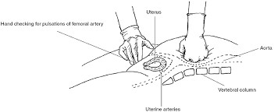


Figure 9: ANTISHOCK GARMENT

If it does not respond, shift the patient to OT and exclude trauma and tissue and proceed to intrauterine tamponade. Vacuum suction cannula (Panicker's vacuum suction cannula, SR Cannula) is a newer, cheap and effective modality available to control bleeding in atonic PPH.

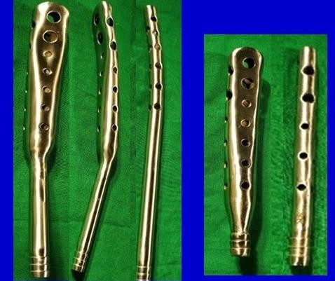

Figure 10: SR Cannula

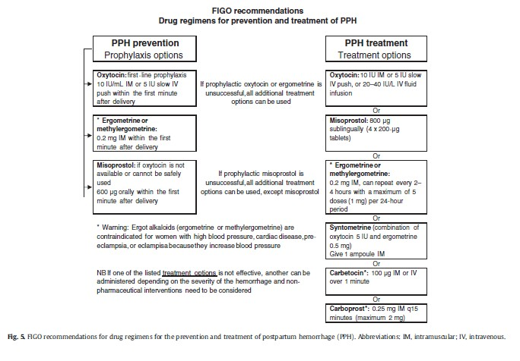

Figure 11: FIGO recommendations for management of PPH

Documentation and Debriefing This of utmost importance.
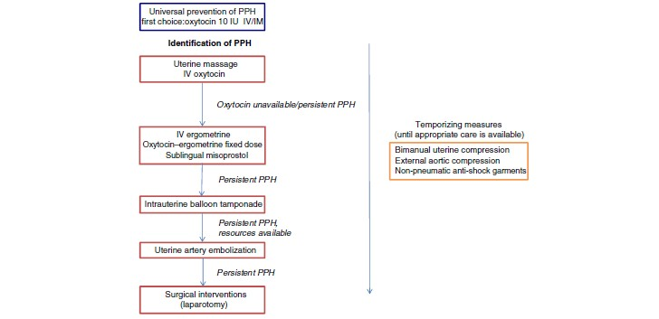

Figure 12: WHO recommendations for PPH treatment
If the initial treatment with uterotonic agents fails, it is always a good option to try mechanical methods before resorting to surgical interventions. Mechanical methods are strongly suggested as an effective treatment modality especially in resource poor settings.^{116,117} It may either arrest bleeding and evade the need for surgical interventions or at least help to buy time while shifting the patient to higher center Bimanual compression:
It is a mechanical method of management of atonic PPH. This maneuver should be commenced as soon as atonic PPH is diagnosed, also be used as a temporary measure while patient is being stabilized for definitive management.

Principle
It acts primarily by stimulating uterine contraction by endogenous release of prostaglandins.¹¹⁸

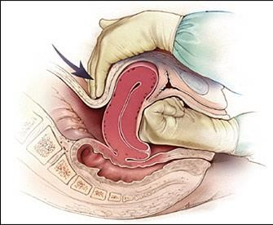

Figure 13: Bimanual Uterine Compression
The compression is continued till the bleeding stops. Assessment of Success is measured by releasing Pressure once in every 2-3 minutes to see if the bleeding is controlled and uterus is well contracted.¹¹⁹
It is a painful procedures Duration of the maneuver is limited by fatigue of the attending healthcare provider.¹¹⁸
UTERINE BALLOON TAMPONADE:
Principle: The exact mechanism of action for the UBT device is unclear. Some of the postulated mechanisms include:
- Direct compression over the bleeding points.¹²⁰
- Release of natural prostaglandins in response to the conformational changes in the uterine cavity caused by the distension media. This is supported by the fact that even 30 mL of distension with a Foley's catheter has been successfully used to control PPH without much of tamponade effect.¹¹⁶
- Stimulation of uterine contractions by the balloon in the cervix has also been demonstrated similar to the Fergusons reflex.¹²¹
Indications of UBT
- Primarily in atonic PPH with ineffective uterotonic medical management.¹¹⁹
- In cases of PPH due to placenta previa, coagulopathy has also been described.¹²²
- It has been also shown to be effective in control of obstetric hemorrhage caused by complex vaginal tears as well as cervical and molar pregnancies.
In 2012, the World Health Organization (WHO) recommended use of the UBT for treatment of uterine atony when uterotonic drugs are unavailable or ineffective2 Current Canadian, British, and American obstetrics society guidelines recommend contemplation of uterine tamponade before other surgical interventions in cases of PPH that are refractory to medical therapy. 5 Case series have reported success rates (i.e. no need for hysterectomy or other invasive procedure) ranging from 71% to 100%.¹¹⁹
PPH Modified menstrual cup/Archit Cup
The PPH cup is an innovative medical device designed to accurately measure blood loss during childbirth. As a modification of menstrual cup,this device addresses a critical gap in maternal healthcare, particularly in managing PPH, which is a leading cause of maternal
mortality worldwide.¹²⁰

The Need for Accurate Measurement
Traditional methods of estimating blood loss during childbirth often rely on visual assessments, which can be inaccurate and lead to delays in diagnosis and treatment. In many cases, it may underestimate the volume of blood lost, resulting in insufficient and delayed in interventions that can jeopardize maternal health. The PPH cup was developed to provide a solution to this problem by offering a reliable and precise method for measuring blood loss.¹²¹
Design and Functionality of the PPH Cup
The PPH cup is inspired by traditional menstrual cups, which are designed to collect menstrual blood. This is modify further to create a device that can provide real-time measurements of blood loss during childbirth. ¹²²

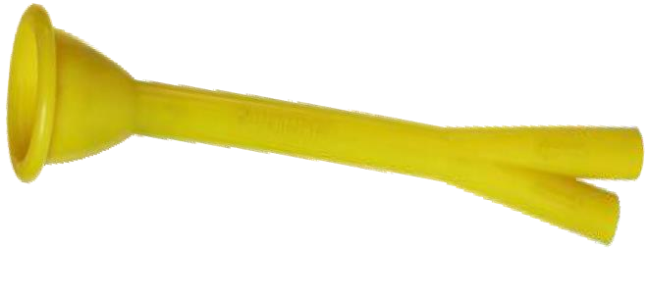

Figure 14: PPH Cup[Archit Cup]
Features OF PPH cup ¹²³
- Material: The PPH cup is made from medical-grade silicone, ensuring safety and biocompatibility.
- Calibration: The cup features specific calibrations that allow accurately quantify the volume of blood collected, thereby facilitating quicker medical responses.
- Usability: Designed for ease of use, the PPH cup can be inserted and remove without difficulty, allowing for quick assessments during critical moments.
- Real-Time Measurement: The cup provides immediate feedback on blood loss, enabling to make informed decisions regarding treatment in golden hour.
- Sterilization: The PPH cup is made of medical-grade silicone, which is a durable and heatresistant material that can withstand sterilization processes.
It can be sterilized using standard methods such as autoclaving, boiling, or chemical disinfection. This allows the cup to be reused safely between patients.

Benefits
- Timely Interventions: By providing precise data on blood loss, the PPH cup allows for quicker medical responses, which can be life-saving during emergencies.
- Reduction in Maternal Mortality: Accurate measurement of blood loss can lead to better management of PPH, ultimately reducing maternal mortality rates associated with childbirth.
- Positive Feedback: Healthcare professionals who have used the PPH cup report improved confidence in managing postpartum hemorrhage and a greater ability to respond to emergencies.
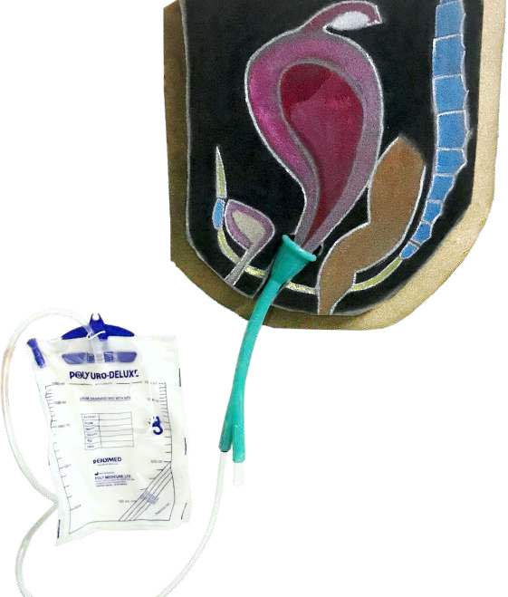



.

Figure 15-WORKING MODEL OF PPH CUP
PPH Cup Integration with Other Medical Devices ¹²³
- Suction Machines:
PPH cup includes a port for attaching a suction device. This feature allows healthcare providers to create negative pressure, which helps in removing blood clots that may obstruct the flow of blood into the cup. By preventing blockages, the suction machine ensures that the measurement of blood loss remains accurate and continuous, which is crucial during critical moments following delivery.
- Blood Collection Bags:
The PPH cup has a dedicated port for connecting to blood collection bags. This enables the direct collection of blood into a sterile bag, facilitating easy measurement of the total blood volume lost. The integration of a blood collection system allows for immediate assessment and management of blood loss, which is vital for timely intervention

- Monitoring Devices:
In a clinical setting, the PPH cup can be used alongside electronic monitoring systems that track vital signs and other parameters of the mother. This integration ensures that healthcare providers can monitor the patient’s condition in real-time while simultaneously measuring blood loss, allowing for a more comprehensive approach to maternal care.
- Infusion Pumps:
In cases where significant blood loss occurs, the PPH cup's accurate measurement can inform the need for fluid resuscitation or blood transfusions. Infusion pumps can be used to administer IV fluids or blood products promptly based on the data provided by the PPH cup, ensuring that the mother receives the necessary treatment without delay.
- Ultrasound and Imaging Devices:
In some cases, ultrasound may be used to assess the uterus for retained products or other complications that could contribute to PPH. The PPH cup’s measurements can guide the need for imaging studies, allowing for a more targeted approach to diagnosis and treatment. ^{123, 124}

MATERIALS AND METHODS
Study setting:
This study was conducted in the Department of Obstetrics and Gynecology tertiary care centre at Government Medical College Akola.
Study design:
This was an observational study.
Study population:
All pregnant mothers who delivered in the study setting during the study period and satisfy the selection criteria for the study.
Study period:
The total duration of the study was 18 months.
Sample size:
This study utilized a sample size of 300 patients.
Sampling technique:
The sampling technique used for the study was universal sampling method.
Ethical considerations in the study:
Ethical clearance was taken from the institutional ethical committee. Ethical Clearance letter is annexed.

Eligibility criteria:
- Inclusion criteria:
patients who delivered in the study setting were considered for the study.
Inclusion criteria are as follows:
Woman with any mode of delivery {normal vaginal delivery/ LSCS}

- Exclusion criteria:
  - Woman who have delivered outside or ambulance deliveries.
  - Women who do not consent to take part in the study.
  - Presence of gynecological comorbidities such as myoma.
  - History of thrombo-embolic disorders.
  - Severe Medical and Surgical Complications including the heart, liver and Kidney, brain and blood disorders.

METHODOLOGY
A cohort of patients was enrolled following ethical committee approval and the acquisition of written informed consent. Upon enrollment, a comprehensive clinical obstetric history and physical examination were conducted to assess each patient condition. A sterile, autoclaved PPH cup was then inserted into the birth canal to accurately measure blood loss following delivery. The cup was maintained in situ for a duration of 2 to 24 hours, depending on the mode of delivery, to monitor for signs of postpartum hemorrhage. To minimize any discomfort during insertion, sterile xylocaine jelly was utilized as a lubricant, and the risk of infection was mitigated by ensuring the use of a sterile, autoclaved cup. The study included various modes of delivery: normal vaginal delivery, operative vaginal delivery, elective lower segment cesarean section (LSCS), and emergency LSCS. The insertion and removal times of the PPH cup were meticulously recorded. Following the procedure, a general and systemic examination was performed, documenting findings such as general condition (GC), pulse rate (PR), blood pressure (BP), and signs of pallor, icterus, or edema. Cardiovascular (CVS), central nervous system (CNS), respiratory system (RS), and abdominal examinations were also conducted to ensure comprehensive assessment of the patients' health status post-delivery.
Statistical analysis
Data was entered into Microsoft Excel version 17 and analysed utilizing Statistical Package for Social Sciences (SPSS). Descriptive format & diagrammatic presentation was done using bar diagram or pie chart as required. For descriptive analysis we used mean, standard deviation, ratio and proportion with percentage. The quantitative data, if required was analysed using independent student’s t test, p<0.05 was be considered as level of statistical significant.

RESULTS AND OBSERVATION
According to metanalysis, due to recent advancement in active management of third stage of labour, availability of better uterotonics, adequate ANC visits, early diagnosis of highrisk case for PPH, labour care guide, assisted delivery by trained obstetrician there is reduced incidence of PPH and associated morbidity and mortality.
Cases which would have been possibly missed, we have picked by use of PPH cup due to timely alarm in golden hour of accurate blood loss measurement and immediate resuscitation.

Table-6: Total participants involved in study groups
Study population | No of cases | Percentage
Tertiary care GMC. Akola | 300 | 100.00%

Graph-1: Graph according to total participants involved in study groups


100.00
%
Study population
Tertiary care GMC. Akola
The study assessing this device involved participants from the tertiary care GMC in Akola, encompassing a total of 300 cases, representing 100% of the study population.

Table-7: Response before Pre placement acceptance
Pre placement acceptance | No of cases | Percentage
Easily acceptance | 192 | 64.00%
On acceptance | 108 | 36.00%

Graph-2: Graph according to Response before Pre placement acceptance


64.00
%
36.00
%
Response before Pre placement
acceptance.
Easily acceptance
On acceptance
The data on pre-placement acceptance indicates that a majority of cases, 64.00% (192 cases), easily accepted their placement. In contrast, 36.00% (108 cases) required some form of persuasion or negotiation before accepting their placement.

Table-8: Response after Post placement acceptance
Post placement acceptance | No of cases | Percentage
Easily accepted with no discomfort | 276 | 92%
Pain full experience | 24 | 8%
Refusal | 0 | 0.00%

Graph-3: Graph according to post placement acceptance


92
%
8
%
0.00
%
Post placement acceptance
Easily accepted with no
discomfort
Pain full experience
Refusal

The post-placement acceptance data reveals that nearly all individuals, 92.00% (276 cases), experienced no discomfort and easily accepted their placements. Only a small fraction, 8.00% (24 cases), reported a painful experience. Notably, there were no cases of outright refusal. This high level of acceptance indicates a generally positive experience with placements, with minimal discomfort reported.
Table-9: Complaints occurred
Complaints | No of cases | Percentage
 | Any fever
Yes | 15 | 5.00%
No | 285 | 95.00%
 | Local infection
Yes | 0 | 0.00%
No | 300 | 100.00%
 | Skin irritation
Skin irritation & Mild discomfort | 21 | 7.00%
No skin irritation/ no discomfort | 279 | 93.00%

Graph-4: Graph according to Complaints occurred


%
5.00
%
95.00
0.00
%
%
100.00
7.00
%
93.00
%
0.00
%
20.00
%
40.00
%
60.00
%
%
80.00
%
100.00
%
120.00
Yes
No
Yes
No
Skin
irritation &
Mild
discomfort
No skin
irritation/
no
discomfort
Any fever
Local infection
Skin irritation
AXIS TITLE
COMPLAINTS
Complaints occured
The data on complaints shows that a vast majority of individuals, 95.00% (285 cases), did not experience any fever, with only 5.00% (15 cases) reporting fever. No cases of local infection were reported, indicating a 100.00% absence of such issues. Additionally, while 93.00% (279 cases) reported no skin irritation or discomfort, 7.00% (21 cases) experienced skin irritation and mild discomfort. This suggests that the incidence of complications or complaints was relatively low.

Table-10: Questionnaire based on obstetrician related
Found helpful in management of PPH due  to easy recognition | No of cases | Percentage
Yes | 300 | 100.00%
Insertion / removal technique/ acceptance
Yes | 300 | 100.00%

Graph-5: Graph according to Questionnaire based on obstetrician related
A)


100.00
%
Found helpful in management of PPH due
to easy recognition
yes

B)

100.00
%
Insertion / removal technique/ acceptance
Yes
The post-partum hemorrhage cup helpful in managing PPH due to its easy recognition. Additionally, 100% reported satisfaction with the insertion, removal techniques, and overall acceptance of the cup
Table-11: patient related parameter
Timely alarm about post-partum bleeding | No of cases | Percentage
Yes | 300 | 100.00%
No | 0 | 0.00%
Shows alarming blood loss in 1 hour indicating PPH through cup inserted | 8 | 2.67%
Normal blood loss post-delivery monitored up  to 24 hr | 292 | 97.33%
Minimizes undue blood transfusion required after excessive blood loss due to
PPH timely alarm by cup within hour [out of 8]
Blood transfusion required | 4 | 50%
Not required | 4 | 50%

Graph-6: Graph according to patient related parameter

A)


B)

100.00
%
0.00
%
Timely alarm about post
-
partum
bleeding
Yes
No


2.67
%
97.33
%
Shows alarming blood loss
Shows alarming blood loss in
1
hour indicating PPH
through cup inserted
Normal blood loss post
delivery monitored up to 24
hr


C)

50
%
50
%
Minimizes undue blood transfusion
required after excessive blood loss due
to PPH timely alarm by cup within
hour [out of 8]
Blood transfusion
required
Not required

The data highlights the effectiveness of timely alarms in managing post-partum hemorrhage (PPH). All 300 cases (100.00%) received timely alarms about post-partum bleeding, and all reported a reduction in the use of sanitary pads and production of sanitary waste. Additionally, timely alarms helped minimize the need for blood transfusions 50%
(4 out of 8 cases) of the instances due to early intervention after excessive blood loss. However, 50% (4 out of 8 cases) required the need for blood transfusions. 2.67% (8 cases out of 300), the device showed alarming blood loss within one hour, indicating the potential onset of PPH. However, in remaining 292 blood loss was normal post-delivery which was monitored up to 24 hours.

Table-12: Mechanical compression device
Mechanical compression device [Bakri balloon/uterine balloon tamponade] | NO OF CASES OF PPH  [OUT OF 8] | PERCENTAGE
YES REQUIRED | 5 | 62.5%
NOT REQUIRED | 3 | 37.5%

Graph-7: Graph according to Mechanical compression device


62.50
%
37.50
%
Mechanical compression device
YES REQUIRED
NOT REQUIRED
The data highlights the effectiveness of timely alarm of PPH and thus the immediate use of additional potent uterotonics such as Oxytocin, Carbetocin, Methergine, Carboprost, and Misoprostol. 62.5% (5 cases out of 8) required mechanical compression methods, while 37.5% (3 cases out of 8) were managed conservatively.

Table-13: Reduction in invasive procedure
Reduction in invasive surgical intervention [uterine artery ligation/internal iliac ligation/obstetric  hysterectomy] | No. of cases [8] | percentage%
Yes | 2 | 25%
No | 6 | 75%

Graph-8: Graph according to reduction in invasive surgical intervention


25
%
75
%
Reduction in invasive surgical
intervention
Yes
No
The data shows that the use of timely alarms significantly contributed to reducing the need for invasive procedures in managing post-partum haemorrhage (PPH). Out of 8 cases, 6 cases (75%) reported a reduction in the requirement for invasive procedures due to early detection and intervention. Meanwhile, 2 cases (25%) required Invasive surgical intervention. indicating the importance of early diagnosis and prompt intervention in reduction of invasive surgical procedure required for management of PPH.

Table-14: Intensive Care Unit management
Intensive care unit admission | No of cases | percentage
YES | 3 | 37.5%
NO | 5 | 62.5%

Graph-9: Graph according to Intensive Care Unit management


37.50
%
62.50
%
Intensive care unit admission
YES
NO

Data showed that timely alarm for post-partum haemorrhage and prompt treatment is effective in reduction of ICU admission.

Table-15: Reduction in hospital stay due to morbidity from post-partum

haemorrhage
Reduction in hospital stay in  cases out of 8 | days | Percentage of reduction  [15-25 days range]
5 | 8 days | 60%
3 | 15 days | 25%

Graph 10- Graph according to Reduction in hospital stay due to morbidity from

post-partum haemorrhage


5
60
%
Reduction in hospital stay
Reduction in hospital stay in
cases out of 8
Percentage of reduction [15-
25
days range
]
The data showed that a timely alarm system for post-partum haemorrhage (PPH) is effective in reducing hospital stay durations. Among the 8 cases observed, 5 cases had to stay for only 8 days thus reducing the hospital stay by a huge percentage of 60%. This suggests that effective measures or interventions were successful in significantly reducing the length of hospital stays for the majority of patients.

Table-16: Reduction in maternal morbidity attributable to PPH
Reduced morbidity | No of cases | Percentage
Yes | 6 | 75%
No | 2 | 25%

Graph- 11: Graph according to Reduction in maternal morbidity attributable to

PPH


75
%
25
%
Reduced morbidity
Yes
No

The data shows this suggests that early diagnosis and immediate interventions were successful in significantly reducing morbidity associated with PPH.

DISCUSSION
Postpartum hemorrhage (PPH) is a significant obstetric emergency and a leading cause of maternal morbidity and mortality worldwide. Defined as excessive bleeding following childbirth, PPH can occur within the first 24 hours postpartum (primary PPH) or up to six weeks later (secondary PPH). The incidence of PPH is influenced by various risk factors, including uterine atony, retained placental tissue, and trauma during delivery. Despite advancements in obstetric care, accurate and timely diagnosis of PPH remains a challenge, often resulting in delayed treatment and adverse outcomes for health of mothers.
Recent studies highlight the importance of precise blood loss measurement in the early detection of PPH. The introduction of modified menstrual cups/PPH CUP designed specifically for this purpose has shown promise in providing timely alerts for excessive blood loss. According to a meta-analysis, due to recent advancements in the active management of the third stage of labor, the availability of better uterotonics, adequate antenatal care (ANC) visits, early diagnosis of high-risk cases for PPH, labor care guidelines, and assisted delivery by trained obstetricians, there has been a notable reduction in the incidence of PPH and its associated morbidity and mortality.
The use of a PPH cup can help identify cases that may have otherwise been missed, as it provides a timely alarm during the critical "golden hour" following delivery. This enables accurate blood loss measurement and immediate resuscitation efforts, significantly improving maternal outcomes. By integrating such innovative tools into clinical practice, healthcare providers can enhance their ability to detect and manage PPH effectively, ultimately reducing the risk of severe complications and fatalities associated with this condition. Therefore, this study aims to assess use of the modified menstrual cup/PPH CUP for the early diagnosis of postpartum hemorrhage, contributing to the broader goal of reducing maternal mortality and morbidity associated with this condition.
This present study utilized a of modified menstrual cups/Archit cup for the early diagnosis of postpartum hemorrhage (PPH) involved a total of 300 participants from the Tertiary Care
Government Medical College in Akola, representing the entirety of the study population (Table 6). This investigation is significant as PPH is a leading cause of maternal morbidity and mortality, and early detection is crucial for effective management. The innovative approach of utilizing modified menstrual cups aims to provide a cost-effective, userfriendly, and non-invasive method for monitoring blood loss during the postpartum period.
Table 7 presents the findings on pre-placement acceptance of the modified menstrual cup among participants in the study, revealing that 192 cases, or 64.00%, reported "easily acceptance," These results highlight a significant level of initial enthusiasm and willingness to adopt the modified menstrual cup, suggesting that a majority of participants found the concept appealing and potentially beneficial for monitoring postpartum hemorrhage. The high percentage of easy acceptance may reflect increasing awareness and openness towards innovative menstrual health solutions, as well as the perceived advantages of using a familiar product in a new context. Conversely, the 36.00% of participants who accepted the cup upon further consideration may indicate a need for additional education or reassurance regarding its use and efficacy in diagnosing postpartum hemorrhage. This dual response pattern underscores the importance of comprehensive educational initiatives to address concerns and enhance acceptance rates, ultimately promoting the adoption of effective health interventions in maternal care. The implications of these findings could inform future strategies for implementing the modified menstrual cup in clinical settings, emphasizing the necessity of tailored communication to maximize acceptance and usage among diverse populations.
In a recent evaluation of post-placement acceptance experiences, the results indicated that a significant majority of participants, 92%, reported being easily accepted with no discomfort, highlighting a positive reception to the procedure. Conversely, 8% experienced a painful experience, while there were no refusals recorded, resulting in a refusal rate of 0.00%. (Table 8) These finding suggest a high level of satisfaction among the majority of individuals, with minimal adverse reactions, emphasizing the effectiveness and acceptability of the placement process. A study conducted in South Africa demonstrated that menstrual cups were generally accepted, with users reporting high satisfaction levels and ease of use compared to traditional sanitary products. ¹²⁵
The Table 9 presented complaints. Out of 300 cases, only 15 (5.00%) reported experiencing fever, while a significant majority, 285 (95.00%), did not report any febrile symptoms, suggesting that the device does not contribute to systemic infections. Notably, there were no reported cases of local infection, indicating that the modified menstrual cup is well-tolerated and does not pose a risk of infection during its use. Furthermore, skin irritation was minimal, with only 21 cases (7.00%) experiencing skin irritation and mild discomfort, while 279 cases (93.00%) reported no skin irritation or discomfort at all. This low incidence of complaints underscores the potential of the modified menstrual cup as a safe and effective tool for monitoring blood loss during the postpartum period, thereby facilitating early diagnosis and management of PPH without significant adverse effects on user comfort or health.

The findings presented in Table 10 indicate a unanimous consensus among the 300 participants, with 100% reporting that the modified menstrual cup was helpful in the management of postpartum hemorrhage (PPH) due to its ease of recognition. This highlights the significant role that the modified menstrual cup can play in facilitating early detection of abnormal blood loss, which is critical for timely intervention. Furthermore, the acceptance of the insertion and removal techniques was also reported at 100%, suggesting that participants found the device user-friendly and practical. This high level of acceptance is crucial, as it underscores the potential for widespread adoption of the modified menstrual cup in clinical settings. The positive feedback regarding both the recognition of PPH and the ease of use of the device points to its viability as a non-invasive, cost-effective tool that could empower healthcare providers and patients alike in the proactive management of postpartum complications, ultimately contributing to improved maternal health outcomes.
The data regarding timely alarms for postpartum bleeding, as presented, reveals a critical aspect of the modified menstrual cup's functionality in managing postpartum hemorrhage (PPH). With 100% of cases indicating that the device provides timely alerts about blood loss, it underscores its effectiveness in enhancing clinical vigilance during the postpartum period. Specifically, the cup identified alarming blood loss indicative of PPH in 8 cases (2.67%), while the vast majority, 292 cases (97.33%), experienced normal blood loss monitored up to 24 hours post-delivery (Table 11). This timely detection is crucial, as it can significantly influence clinical decision-making and patient outcomes. Among the 8 cases where alarming blood loss was detected, blood transfusion was required in 4 cases (50%), while the other 4 cases (50%) did not necessitate transfusion, highlighting the cup's potential to minimize unnecessary blood transfusions through early detection and intervention. Overall, these findings suggest that the modified menstrual cup not only aids in the accurate monitoring of blood loss but also plays a vital role in timely diagnosis and management of PPH.
The Table 12 presented indicates that among the 8 cases where alarming blood loss was detected using the modified menstrual cup, mechanical compression devices such as the Bakri balloon or uterine balloon tamponade were required in 5 cases (62.5%) to manage postpartum hemorrhage (PPH). In the remaining 3 cases (37.5%), were managed conservatively not required compression device .
The use of intrauterine balloon tamponade devices has been well-established in the management of refractory PPH. These devices work by compressing the uterine walls and vasculature, thereby reducing blood flow and allowing the uterus to contract and expel clots. Research done by Liu LY et al and Futcher F. et al ^{126, 127} demonstrated their efficacy in controlling PPH secondary to uterine atony, with success rates ranging from 80-92%.
The high percentage (62.5%) of cases requiring mechanical compression in this study underscores the severity of PPH in these instances. Prompt recognition of alarming blood loss by the modified menstrual cup likely facilitated timely placement of these devices, contributing to their success in controlling the hemorrhage. However, it is important to note that in over one-third of cases, the cup's alarm alone was sufficient, highlighting its potential to guide targeted interventions and minimize unnecessary use of invasive procedures.

This finding suggests that the modified menstrual cup can effectively identify severe PPH cases requiring mechanical compression devices, enabling prompt and appropriate management.
The reduction in invasive surgical interventions for postpartum hemorrhage (PPH) reveals that out of 8 cases where alarming blood loss was detected, only 2 cases (25%) required invasive procedures such as uterine artery ligation, internal iliac ligation, or obstetric hysterectomy, while a significant majority, 6 cases (75%), did not necessitate any surgical intervention (Table 13). This finding highlights the effectiveness of timely recognition and management strategies, including the use of the modified menstrual cup, which likely facilitated early intervention and stabilization of patients experiencing PPH. The ability to manage these cases conservatively rather than resorting to more invasive surgical options is crucial, as it not only reduces the associated risks and complications of surgery but also promotes quicker recovery and better overall maternal outcomes. Furthermore, the data suggests that the modified menstrual cup/PPH CUP can play a vital role in minimizing the need for invasive surgical interventions in PPH cases, highlighting its potential as an essential tool in postpartum care and emphasizing the importance of early detection and management in improving maternal health outcomes.
The Intensive Care Unit (ICU) management indicates that out of 8 cases of postpartum hemorrhage (PPH) detected using the modified menstrual cup, 3 cases (37.5%) required admission to the ICU, while 5 cases (62.5%) did not necessitate such intensive care Table14. This distribution highlights the varying severity of PPH among the cases monitored, suggesting that while some patients experienced significant complications requiring closer observation and advanced medical support, the majority were able to be managed effectively without the need for ICU resources. The relatively low percentage of ICU admissions underscores the potential effectiveness of the modified menstrual cup in facilitating timely diagnosis and intervention, allowing for appropriate management strategies to be implemented before the condition escalates to a critical level.
Table-15 illustrates the reduction in hospital stay due to morbidity associated with postpartum hemorrhage (PPH), showing that out of 8 cases, 5 patients experienced a reduction of 8 days in their hospital stay, representing a significant 60% reduction, while 3 patients had a reduction of 15 days, equating to a 25% reduction. This data suggests that the timely detection and management of PPH, facilitated by the use of the modified menstrual cup, can lead to shorter hospitalizations, thereby enhancing patient recovery and reducing healthcare costs. The substantial reduction in hospital stay for the majority of cases indicates that effective early intervention not only mitigates the severity of complications associated with PPH but also allows patients to return to their normal lives more quickly.
The data presented in Table-16 demonstrates the reduction in maternal morbidity attributable to postpartum hemorrhage (PPH) when using the modified menstrual cup. Out of the 8 cases where alarming blood loss was detected, 6 cases (75%) experienced reduced morbidity, while 2 cases (25%) have to suffer. This significant reduction in morbidity highlights the effectiveness of the modified menstrual cup in facilitating early diagnosis and management of PPH, which is crucial in preventing long-term complications and improving maternal health outcomes. By promptly identifying excessive blood loss, healthcare providers can implement appropriate interventions, such as uterine balloon tamponade or surgical procedures, to control the bleeding and minimize the risk of severe complications like organ dysfunction, shock, or even death. The high percentage of cases with reduced morbidity underscores the potential of the modified menstrual cup as a valuable tool in postpartum care, contributing to a decrease in maternal mortality and morbidity associated with PPH.
Moreover, this present study shows that the modified menstrual cup for early diagnosis of postpartum hemorrhage (PPH) represents a significant advancement in maternal healthcare, marking the first instance of utilizing a PPH cup specifically designed for this purpose. This innovative device, inspired by traditional menstrual cups, enables healthcare providers to accurately measure blood loss during the critical moments following childbirth, thereby facilitating timely intervention and potentially reducing maternal mortality rates associated with PPH. By providing real-time data on blood loss, the PPH cup addresses a critical gap in current practices, where visual estimation often leads to delays in diagnosis and treatment. This pioneering approach not only enhances the management of postpartum hemorrhage but also showcases the potential of repurposing menstrual health technologies to improve maternal outcomes in clinical settings.

SUMMARY
- The present study was an observational study aimed to asses and use of modified menstrual cup/PPH CUP for the early diagnosis of postpartum haemorrhage (PPH).
- The present study conducted over 18 months at the Department of Gynecology in a tertiary care center at Government Medical College, Akola, the study included 300 patients who met the inclusion criteria. Ethical approval for the study was obtained from the institutional ethics committee before its initiation.
- Recent advancements in the active management of the third stage of labour, including the availability of better uterotonics, adequate antenatal care visits, and early diagnosis of high-risk cases for PPH, have contributed to a reduced incidence of PPH and its associated morbidity and mortality. The modified menstrual cup was utilized to identify cases that might have been missed otherwise, providing a timely alarm during the critical "golden hour" for accurate blood loss measurement and immediate resuscitation.
- The study population comprised a total of 300 cases, representing 100% of participants involved in the study. Data on pre-placement acceptance revealed that
64% (192 cases) easily accepted the placement of the menstrual cup, while 36% (108 cases) required some persuasion. Following placement, the post-placement acceptance data indicated that 92% (276 cases) experienced no discomfort, with only 8% (24 cases) reporting a painful experience, and no refusals recorded.
- Regarding complaints, the majority of participants (95%, or 285 cases) did not experience fever, and no cases of local infection were reported. However, 7% (21 cases) experienced skin irritation and mild discomfort. The questionnaire responses from obstetricians/obgy resident indicated that the menstrual cup/PPH CUP was deemed helpful in managing PPH due to its easy recognition, with 100% satisfaction reported regarding insertion and removal techniques.
- The device provided timely alarms about postpartum bleeding in all cases, with 2.67% (8 cases) alarming blood loss indicating PPH within one hour, while the remaining 97.33% (292 cases) exhibited normal blood loss monitored up to 24 hours. This early intervention minimized the need for blood transfusions in 50% of cases where excessive blood loss was detected. Additionally, 62.5% of cases requiring mechanical compression methods were managed effectively, while 75% of cases reported a reduction in the need for invasive procedures due to early detection and intervention.
- The data also highlighted a reduction in intensive care unit admissions, with only 37.5% (3 cases) requiring such care. Furthermore, timely alarms contributed to a significant reduction in hospital stays, with 60% of cases staying only 8 days and
25% staying 15 days, indicating effective management of PPH-related morbidity. Overall, 75% of participants reported reduced morbidity attributable to PPH, underscoring the importance of early diagnosis and prompt intervention in improving maternal outcomes.

CONCLUSION
This present study aimed to assess use of modified menstrual cup/Archit cup for early diagnosis of postpartum haemorrhage(PPH) and found significant results supporting its utility. With a total of 300 cases from a tertiary care center, the data revealed that the cup facilitated timely alarms for blood loss, allowing for immediate intervention, which is critical during the golden hour post-delivery. The high acceptance rates before and after placement (64% and 92%, respectively) indicate that patients generally found the device comfortable and effective, with minimal complaints reported. Notably, 100% of patients gave timely alarm and accurate measurement post delivery blood loss , hence acknowledged the device's role in recognizing PPH, and the timely alerts contributed to a 62.5% requirement for mechanical compression methods, reducing the need for invasive surgical interventions in 75% of cases. Furthermore, the study highlighted a significant reduction in hospital stays and maternal morbidity associated with PPH, underscoring the importance of early detection and intervention. These findings suggest that the modified menstrual cup/PPH CUP is a valuable tool in realtime and accurate estimation of post partum haemorrhage so as to save life of mothers in “Golden hour’’ potentially improving
maternal outcomes through enhanced monitoring and timely medical responses.

REFERENCES
- Lothian JA. Safe, Healthy birth. What every pregnant woman needs to know. J Perinat
Educ. 2009;18(3);48-54.
- Ronsmons C, Grahane WJ. Maternal mortality: who, when, where and why. Lancet
2006; 368 (9542):1189 – 200.
- WHO recommendation on tranexemic acid for the treatment of postpartum haemorrhage. [Online]. 2014. [Cited on Sep 21]; Available from: URL:
http://apps.who.int/iris/bitstream/handle/10665/259374/9789241550154eng.pdf;jsessionid=8DE85D7BA0BAF313AE8E93A01212C3E2?sequence=1
- Moodley J, Pattinson RC, Fawcus S, Schoon MG, Shewni PM. The confidential enquiry into maternal deaths in south Africa-a case study. [Online]. 2014. [Cited on
Sep 21]; Available from: URL:
https://obgyn.onlinelibrary.wiley.com/doi/pdf/10.1111/1471-0528.12869
- Thieren S. The use of tranxemic acid in pregnant women in the prevention and management of postpartum bleeding. [Online]. 2017. [Cited on Sep 21]; Available from: URL: https://www.scriptiebank.be/sites/default/files/thesis/2017-
09/PPH%20and%20tranexamic%20acid_Sabine%20Thieren_final.pdf
- www.searo.who.int/mediacentre/features/2018/india-groundbreaking-sucess-
reducing-maternal-mortality-rate/en accessed on 24.11.2018.
- https://timesofindia.indiatimes.com/india/maternal-mortality-drops-to-130-kerala- top-big-improvement-in-backward-states/articleshow/64486279.cmsaccessedon
25.11.2018
- Dahlke JD, Mendez-Figueroa H, Maggio L, et al. Prevention and management of postpartum hemorrhage: a comparison of 4 national guidelines. Am J Obstet
Gynecol. 2015:213(1):76 e1-10.
- Rath WH. Postpartum hemorrhage: update on problems of definitions and diagnosis. Acta Obstet Gynecol Scand. 2011;90(5):421-8.
- Lalonade A. prevention and treatment of postpartum hemorrhage in low-resource settinq. Int J Gynaecol Obstet. 2012:117(2):108-18.
- Committee on Practice Bulletins-Obstetrics practice bulletin No. 183: Postpartum
Hemorrhage. Obstet Gynaecol. 2017;130:e168-86.
- Royal College of Obstetrician and Gynecologist. Postpartum Hemorrhage prevention
and management (Green-Top guideline no. 52) London: RCOG; 2009.
https://www.rcog.org.uk/en/guidelines-research-services/guidelines/gtg52/accessed on 24.10.2018
- Leduc D, Senikas V, Lalonde AB, et el. Active management of third stage of labour: Prevention and treatment of postpartum hemorrhage. It J Gynaecol Obstet. 2010:108:258-67.
- Royal Australian and New Zealand College of Obstetricians and Gynaecologist.Management of postpartum hemorrhage (PPH). 2011.
https://www.ranzcog.edu.au/.../Obstetrics/Postpartum-Hemorrhage,-ManagementofPPH. Accessed On 30.11.2018
- Shripad H, Rai L, Mohan A. Comparison of blood loss in induced vs spontaneous vaginal delivery using specialized blood collection bag. J Clin Dian Res. 2014; 8:0C01-
4.
- Bonnar J. Massive obstetric hemorrhage: Best pract. Res Clin Obstet Gynaecol.2000:14:1-18.
- Nathan HL, Cottam K, Hezelgrave NL, et al. Determination of normal ranges of shock index and other haemodynamic variables in the immediate postpartum periods:a cohort study. PLoS One. 2016;11e0168535.
- El Ayadi AM, Nathan HL, Seed PT, et al. Vital Signs prediction of adverse maternal outcome in women with hypovolemic shock: the role of shock index. PLoS One.
2016;11:1-12.
- Devine PC. Obstetric hemorrhage. Semin Perinatol. 2009;33(2):76-81.
- Lockwood C, Krikun G, Schatz F. The decidua regulates hemostasis in human endometrium. Semin Reprod Endocrinol. 1999;17(1):45-51.
- Brennand J, Leask R, Kelly R, et al. The influence of amniotic fluid on prostaglandin synthesis and metabolism in human fetal membranes. Acta Obstet Gynecol Scand.1998;77(2):142-50.
- Bateman BT, Berman MF, Riley LE, et al. The epidemiology of postpartum hemorrhage in a large, nationwide sample of deliveries. Anesth Analg. 2010;110(5):1368-73.
- Conrad LB, Groome LJ, Black DR. Management of Persistent Postpartum Hemorrhage
Caused by Inner Myometrial Lacerations. Obstet Gynecol. 2015;126(2):266-9.
- Tower C. Obstetric Emergencies. In: Baker PN, Kenny LC (Eds). Obstetrics by Ten Teachers, 19th edition. New York: CRC Press Taylor & Francis Group; 2011. pp. 241-
55.
- Baskett TF. Postpartum Hemorrhage. In: Baskett TF, Calder AA, Arulkumaran S
(Eds). Munro Kerr's Operative Obstetrics, 12th edition. International ed: Saunders Elsevier; 2014. pp.198-206.
- Konje J, Whalley R. Bleeding in late pregnancy. In: James D, Steer P, Weiner C, Gonik B (Eds). High-risk Pregnancy Management Options. London: Saunders; 1994. pp. 119-
36.
- Roberston WB, Khong TY, Brosens I, et al. The placental bed biopsy: review from three European centres. Am J Obstet Gynecol. 1986;155(2):401-12.
- Kingdom JCP. Antepartum Hemorrhage. In: Baskett TF, Calder AA, Arulkumaran S
(Eds). Munro Kerr's Operative Obstetrics, 12th edition. International ed: Saunders Elsevier; 2014. pp.178-97.
- Royal College of Obstetricians and Gynecologists. Placenta praevia and placenta praevia accreta: diagnosis and management. Green-top Guideline No. 27a. London:
RCOG; 2018.
- Groom KM, Jacobson TZ. The management of secondary postpartum hemorrhage. In:
B-Lynch C (Ed). A Textbook of Postpartum Hemorrhage. Sapiens Publishing; 2006.
- ACOG_Practice_Bulletin_No_183_Postpartum-Hemorrhage-2017.pdf.
- WHO Recommendations for the Prevention and Treatment of Postpartum
Haemorrhage. Geneva: World Health Organization; 2012. http://apps.who. int/iris/bitstream/handle/10665/75411/9789241548502_eng.pdfijsessionid
=2B18FBOFE638F925560D45BC1A098717?sequence=1. Accessed on 26/10/21.
- Rogers J, Wood J, McCandlish R, Ayers S, Truesdale A, Elbourne D. Active versus expectant management of third stage of labour: the Hinchingbrookerandomised controlled trial. 1998;7:693-699.
- Henriquez DD, Bloemenkamp KW, Born JG. Management of postpartum haemorrhage: how to improve maternal outcomes. Journal of thrombosis and haemostatsis.2018;16(8):1523-1534
- Keirse, 1998 – Therese A, Weigers, Zee JV, Keirese. Maternity Care in The Netherlands: The Changing Home Birth Rate. Wiley online library – Birth. 2008;25:190-197
- McDonald, 2003 - Corwin EJ, Murray-Kolb LE, Beard JL. Low hemoglobin level is a risk factor for postpartum depression. J Nutr2003;133:4139-42.
- Prendiville et al., 2003 - Mousa HA, Alfirevic Z. Treatment for primary postpartum haemorrhage. Cochrane Database Syst Rev 2003;(1):CD003249.
- Cochrane database systematic reviews 2004 – McDonald S, Abott JM. Prophylactic ergometrine-oxytocin versus oxytocin for the third stage of labour. The Cochrane
database of systematic review 2004;20. Available from URL:
https://www.ncbi.nlm.nih.gov/pmc/articles/PMC6491201/pdf/CD000201.pdf
- Gulmezoglu A, Lumbiganon P, Landoulsi S. Active management of the third stage of labour with and without controlled cord traction. Lancet. 379(9827):1721–7.
- Oguz Oran E, Dilbaz B, Aksakal SE, et al. Prospective randomized trial of oxytocin administration for active management of the third stage of labor. Int J Gynecol Obstet.2014;127(2):175-9.
- Güngördük K, Asicioglu O, Besimoglu B, et al. Using intraumbilical vein injection of oxytocin in routine practice with active management of the third stage of labor: a randomized controlled trial. Obstet Gynecol.2010;116(3):619-24.
- McDonald SJ, Abbott JM, Higgins SP. Prophylactic ergometrine-oxytocin versus oxytocin for the third stage of labor. Cochrane Database Sys Rev. 2004;(1):CD000201.
- Zhu C, Estrada M, White J, et al. Heat-stable sublingual oxytocin tablets as a potential needle-free approach for preventing postpartum hemorrhage in low- resource settings.
Drug Deliv Transl Res. 2018;8:853-6.
- pph fogsi.pdf.
- Prevention and Management of Postpartum Haemorrhage: Green-top Guideline No.
  - BJOG Int J Obstet Gynaecol. 2017 Apr;124(5):e106–49.
- Bond GR, Van Zee A. Overdosage of misoprostol in pregnancy. Am J Obstet Gynecol.1994;171:561-2.
- Hernández-Castro F, López-Serna N, Treviño-Salinas EM, et al. Randomized doubleblind placebo-controlled trial of buccal misoprostol to reduce the need for additional uterotonic drugs during cesarean delivery. Int J Gynecol Obstet. 2016;132(2):184-7.
- Prevention and Management of Postpartum Haemorrhage: Green-top Guideline No.
  - BJOG Int J Obstet Gynaecol. 2017 Apr;124(5):e106–49.
- D. Cordovani, J. C. A. Carvalho, M. Boucher and D. Farin., Carbetocin for the
Prevention of Postpartum Hemorrhage. Available at https://www.ferring.ca/media/1253/eng-duratocin-vial-pm-eng-21feb2020.pdf_ accessed on 18th Sep 2021.
- A. Brenner et al. / Best Practice & Research Clinical Obstetrics and Gynaecology 61 (2019) 66e74
- Okamoto S, Okamoto U. Amino-methyl-cyclohexane-carboxylic acid: AMCHA. A
New Potent Inhibitor of the Fibrinolysis, 11; 1962.
- Callender ST, Warner GT, Cope E. Treatment of menorrhagia with tranexamic acid. A double-blind trial. Br Med J. 1970;4(5729):214–216. [PubMed: 4919554]
- Shakur H, Beaumont D, Pavord S, et al. Antifibrinolytic drugs for treating primary postpartum haemorrhage. Cochrane Database Syst Rev. 2018;2:CD012964. [PubMed: 29462500]
- Sentilhes L, Winer N, Azria E, et al. Tranexamic acid for the prevention of blood loss after vaginal delivery. N Engl J Med. 2018;379(8):731–742. [PubMed: 30134136]
- Dunn and Goa. Tranexamic acid: a review of its use in surgery and other indications.
Drugs 1999; 57 (6): 1005-32.
- Martindale pg 1164
- Anderson L, Nilsson IM, Nilehn JE, et al. Experimental & clinical studies on AMCA, the antifibrinolytic active isomer of P- aminomethyl cyclohexane carboxylic acid was done. Scand J Haemato 1965:2:230-47
- Pilbrant A, Schannong M, Vessman J. Pharmacokinetics & bioavailability of tranexamic acid. Eur J ClinPharmacol 1981; 20 65- 72
- Widlund L, Stromberg S, Hellstrom H, et al. The disposition of tranexamic acid
(AMCA) in various animal species & in man after oral dosage was evaluated. Stockholm, Sweden: Kabi AB 1979
- Tovi D, Thulin CA. The ability of tranexamic acid to cross the blood brain barrier & its use in patients with ruptured intracranial aneurysms. ActaNeurolScand 1972; 48:257
- Ahlberg A, Eriksson O, Kjellman H. Diffusion of tranexamic acid to the joint. ActaOrthopScand 1970: 49:241-2
- Walzman M, Bonnar J. Effects of tranexamic acid in human milk after oral administration of tranexamic acid in lactating women. Stockholm, Sweden: Kabi AB, 1971
- Lethaby, 2000 - Halder S, Samanta B, Sardar R, Chattopadhyay S. Tranexamic acid used before section reduces blood loss based on pre‐ and postoperative hemoglobin level: a case‐control study. Journal of the Indian Medical Association 2013;111(3):184‐6.
- Pili ferrer et al., 2009). - Ferrer P, Roberts I, Sydenham E, Blackhall K, Shakur H. Antifibrinolytic agents in post partumhaemorrhage: a systematic review. BMC Pregnancy Childbirth. 2009;9:27-29.
- Gohel et al., 2007 - Ramani B et al. Int J Reprod Contracept Obstet Gynecol. 2014 Jun;3(2):366-369
- Gai et al., 2004 – Knight M, Callaghan WM, Berg C, Alexander S, Colle MH et al.
Trends in postpartum hemorrhage in high resource countries: a review and recommendations from the International Postpartum Hemorrhage Collaborative Group. BMC Pregnancy and childbirth. 2009;55:1-12.
- Gakhan Yildirim et al., 2011 – Gungorduk K, Asicioglu O, Yildrim G. Trends in postpartum hemorrhage in high resource countries: a review and recommendations from the International Postpartum Hemorrhage Collaborative Group. Australian and New Zealand Journal of Obstetrics and Gynaecology.2011; 51: p. 441-445
- Novikova N. et al., 2010 – Novikova N, Hofmeyr GJ. Tranexamic acid for preventing postpartum haemorrhage. Cochrane Database of Systematic Reviews. 2015;6:1-12
- J Bonner et al., 2011 - Bonner J. Massive obstetric hemorrhage. Baillieres Best Practice and Research in Clinical obstetrics and Gynaecol2011;14:1-18.
- Welsh, 2008 Welsh A, McLintock C, Gatt S, Somerset D, Popham P, Ogle R. Guidelines for the use of recombinant activated factor VII in massive obstetric haemorrhage. Aust N Z J ObstetGynaecol. 2008;48(1):12-16
- Clinical textbook of obstetric and gynaecology 2010). - Cunningham, F. Gary,, et al. Williams Obstetrics. 24th edition. New York: McGraw-Hill Education, 2014.
- Sheppard BL, Bonnar J. The ultra-structure of the arterial supply of the human placenta in early & late pregnancy. J ObstetGynaecol Br Commonw 1974; 81:497-511
- Sheppard BL, Bonnar J. Fibrinolysis in decidual spiral arteries in late pregnancy. ThrombHaemost 1978; 39:751-7
- Tunçalp Ö, et al, NewWHO recommendations on prevention and treatment of
postpartum hemorrhage, Int J Gynecol Obstet (2013),
http://dx.doi.org/10.1016/j.ijgo.2013.06.024.
- 6. Committee on Trauma. Advanced Trauma Life Support Manual. Chicago: Am Coll
Surg. 1997. pp. 103-12.
- Duthie SJ, Ghosh A, Ng A, et al. Intraoperative blood loss during elective lower segment caesarean section. BJOG. 1992:99:364-7.
- Dodson MK, Magann EF, Chauhan SP, et al. Accuracy of blood loss estimation and measurement at cesarean birth. J Matern-Fet Neonat Med. 1994;3(4):171-4.
- Stafford I, Dildy GA, Clark SL, et al. Visually estimated and calculated blood loss in vaginal and caesarean delivery. Am J Obstet Gynecol. 2008;199(5):519e1-7.
- Larson C, Saltvedt S, Wilkone S, et al. Estimation of blood loss after caesarean section and vaginal delivery has low validity with tendency to exaggeration. ActaObstet Gynecol Sand. 2006;85(12):1448-52.
- Schorn MN. Measurement of blood loss: Review of the literature. J Midwifery Women's Health. 2010;55(1):20-7.
- Newton M. Postpartum hemorrhage. Am J Obstet Gynecol. 1966;94:711-6.
- Buckland SS, Homer CS. Estimating blood loss after birth: Using simulated clinical examples. Women Birth. 2007:20(2):85-8.
- Bose P, Regan F, Paterson-Brown S. Improving the accuracy of estimated blood loss at obstetric hemorrhage using clinical reconstructions. BJOG.2006;113(8):919-24.
- Prata N, Mbaruku G, Campbell M. Using the kanga to measure postpartum blood loss.
Int J Gynaecol Obstet. 2005;89(1):49-50.
- Kodkany BS, Derman RJ, Goudar SS, et al. Initiating a novel therapy in preventing postpartum hemorrhage in rural India: a joint collaboration between the United States and India. Int J Fertil Women Med. 2004;49(2):91-6.
- Patel A, Goudar SS, Geller SE, et al. Drape estimation vs. visual assessment for estimating postpartum hemorrhage. It J Gynecol Obstet. 2006:93(3):220-4.
- Kodkany BS, Derman RJ. Pitfalls in assessing blood loss and decision to transfer. In: Lynch C-B, Keith L, Lalonde A, Karoshi M (Eds). A Textbook of Postpartum Hemorrhage. Dumfries: Sapiens Publishing; 2006. pp. 35-44.
- Derman RJ, Kodkany BS, Goudar SS, et al. Oral misoprostol in preventing postpartum hemorrhage in resource-poor communities: a randomized controlled trial. Lancet. 2006;368(9543):1248-53.
- Tourne G, Collet F, Lanier P, et al. Usefulness of a collecting bag for the diagnosis of post-partum hemorrhage. J Gynecol Obstet Biol Reprod. 2004;33:229-34.
- Prata N, Qualyum M, Shahed Hossain S, et al. Community-based prevention of PPH in rural Bangladesh. Presented at the 138th Meeting of the American Public Health Association (APHA), Denver, CO, November; 2010.
- Chua S, Ho LM, Vanaja K, et al. Validation of a laboratory method of measuring postpartum blood loss. Gynecol Obstet Invest. 1998;46(1):31-3.
- Wilcox CF, Hunt AB, Owen CA. The measurement of blood lost during cesarean section. Am J Obstet Gynecol. 1959;77(4):772-9.
- Whittaker PG, Macphail S, Lind T. Serial hematologic changes and pregnancy outcome. Obstet Gynecol. 1996;88(1):33-9.
- Brecher ME, Monk T, Goodnough LT. A standardized method for calculating blood loss. Transfusion. 1997;37(10):1070-4.
- Main EK, Cape V, Abreo A, et al. Reduction of severe maternal morbidity from haemorrhage using a state perinatal quality collaborative. Am J Obstet Gynecol. 2017; 216:298. e1-11.
- Creanga AA, Berg C, Ko JY, et al. Maternal mortality and morbidity in the United States: where are we now? J Womens Health (Larchmt). 2014;23(1):3-9.
- Mavrides E, Allard S, Chandraharan E, et al. Prevention and management of postpartum hemorrhage. BJOG.2016;124:106-e149.
- Melanie F Cole. A modified early obstetric warning system. Br J Midwifery. 2014;
22(12):862-8.
- Mackitosh N, Watson K, Rance S, et al. Value of a modified early obstetric warning system in management of maternal complications in peripartum period: an ethnographic study. BMJ Qual Saf. 2014;23(1):26-34.
- Centre for Maternal and Child Enquiries (CMACE). Saving mother's lives: reviewing maternal deaths to make motherhood safer: 2006-08. The eighth report on Confidential Enquiries into Maternal deaths in United Kingdom. 2011;118:1-203.
- Muhammad S, Chandraharan E. Postpartum Haemorrhage. In: Arias F, Bhide A, Damania K (Eds). Arias' Practical guide to high risk pregnancy and delivery, 4th edition; 2015. pp. 389-98.
- Le Bas A, Chandraharan E, Addei A, et al. Use of the "obstetric shock index" as an adjunct in identifying significant blood loss in patients with massive postpartum hemorrhage. Int J Gynaecol Obstet. 2014:124(3):253-5.
- Varatharajan L, Chandraharan E, Sutton J, et al. Outcome of the management of massive postpartum hemorrhage using the algorithm " HEMOSTASIS". IntJ Gynaecol Obstet. 2011;113(2):152-4.
- De Jonge E, Levi M. Effects of different plasma substitute on blood coagulation: a comparative review. Crit Care Med. 2001:29:1261-7.
- Tanake KA, Slam F. Treatment of massive bleeding with prothrombin complex concentrate: argument for. J Thromb Haemost. 2010;8(12):2589-91.
- Lyndon A, Lagrew D, Shields L, Main E, Cape V (Eds). Improving health care response to obstetric hemorrhage version 2.0. A California quality improvement toolkit. Stamford (CA): California Maternal Quality Care Collaborative; Sacramento (CA): California Department of Public Health; 2015.
- Treml AB, Gorlin JB, Dutton RP, et al. Massive Transfusion protocols: a survey of academic medical centers in the United States. Anesth Analg.2017;124(1):277-81
- Hunt BJ, Allard S, Keeling D, et al. A practical guideline for the haematological management of major hemorrhage. Br J Haematol.2015;170(6):788-803.
- Anderson M, Etches D. Prevention and management of postpartum hemorrhage, Am Fam Physician. 2007;75:875-82.
- Management of PPH. Women's Health Committee. RANZCOG Board and
Council: 2017.
- Bateman BT, Berman MF, Riley LE, et al. The epidemiology of postpartum hemorrhage in a large nationwide sample of deliveries. Anaesth
Analg.2010;110(5):1368-73.
- Su LL, Chong YS, Samuel M. Oxytocin agonists for preventing postpartum hemorrhage. Cochrane Database of Systematic Reviews. 2007;3:CD005457.
- Effect of early tranexamic acid administration on mortality, hysterectomy and other morbidities in women with postpartum hemorrhage (WOMAN): an international randomised double blinded placebo-controlled trial. WOMAN Trial Collaborators. Lancet. 2017;389:2105-16.
- Keogh J, Tsokos N. Aortic compression in massive postpartum haemorrhage-an old but lifesaving technique. Aust N J Obstet Gynaecol. 1997;37(2):237-8.
- Tunçalp Ö, et al, NewWHO recommendations on prevention and treatment of
postpartum hemorrhage, Int J Gynecol Obstet (2013),
http://dx.doi.org/10.1016/j.ijgo.2013.06.024
- Tindell K, Garfinkel R, Abu-Haydar E, et al. Uterine balloon tamponade for the treatment of postpartum hemorrhage in resource-poor settings: a systematic review. BJOG.2013;120:5-14.
- Herrick T, Mvundura M, Burke TF, et al. A low-cost uterine balloon tamponade for management of postpartum hemorrhage: modeling the potential impact on maternal mortality and morbidity in sub-Saharan Africa. BMC Pregnancy anc Childbirth. 2017:17:374.
- Lim PS. Uterine Atony: Management Strategies, Chapter 6, Intech Open Accesses Publisher 2012; 97-128. Do:10.5772/33272
- WHO quidelines for the management of postpartum hemorrhage and retained placenta. Geneva: World Health Organization; 2012. apps.who.int/iris/bitstrean handle/10665/44171/9789241598514_eng.pdf
- https://csrbox.org/Impact/description/Impact-stories_full_RevolutionisingMaternal-Care--15-YO-Prodigy-Designs-Life-Saving-Device-Inspired-by-MenstrualCups_649#:~:text=Archit%20created%20and%20constructed%20his,keeping%20off %20many%20maternal%20fatalities.
- Akter S, Lorencatto F, Forbes G, Miller S, Althabe F, Coomarasamy A, Gallos ID, Oladapo OT, Vogel JP, Thomas E, Bohren MA. Perceptions and experiences of the prevention, identification and management of postpartum haemorrhage: a qualitative evidence synthesis. Cochrane Database of Systematic Reviews. 2020 Dec 4;2020(12).
- Singh R, Agarwal M, Sinha S, Chaudhary N, Sinha HH, Anant M.
Study of Adaptability and Efficacy of Menstrual Cups in Managing
Menstrual Health and Hygiene: A Descriptive Longitudinal Study. Cureus.
2022;14(9):e29690. Published 2022 Sep 28. doi:10.7759/cureus.29690
- https://thebetterindia.com/265751/childrens-day-india-child-prodigytalent-innovation-rashtriya-bal-shakti-puraskar/
- Panicker TN. Panicker's Vacuum Suction Haemostatic Device for Treating Post-Partum Haemorrhage. J Obstet Gynaecol India. 2017;67(2):150-151.
doi:10.1007/s13224-017-0963-x
- Wunsch N, Green SJ, Adam S, Hampton J, Phillips-Howard PA, Mehta SD. In Vitro Study to Assess Effective Cleaning Techniques for
Removing Staphylococcus aureus from Menstrual Cups. International Journal of Environmental Research and Public Health. 2022; 19(3):1450.
https://doi.org/10.3390/ijerph19031450
- Liu LY, Nathan L, Sheen JJ, Goffman D. Review of Current Insights and Therapeutic Approaches for the Treatment of Refractory Postpartum Hemorrhage. Int J Womens Health. 2023;15:905-926. Published 2023 Jun 1. doi:10.2147/IJWH.S366675
- Futcher F, Moufawad G, Centini G, et al. Intrauterine Tamponade Balloon for Management of Severe Postpartum Haemorrhage: Does Early Insertion Change the Outcome? A Retrospective Study on Blood Loss. J Clin Med. 2023;12(17):5439. Published 2023 Aug 22. doi:10.3390/jcm12175439

PROFORMA

ANNEXURES-1
Participant Record Form (Confidential)
NAME:
MRD NO:
AGE:
Diagnosis:
High Risk Factors (if any):
Parity Status:

Management During 3rd Stage of Labour
Type of Uterotonic Used:
- Pitocin-
- Carbetocin -

Mode of Delivery
- Normal Vaginal Delivery- • Operative Vaginal Delivery-
- Elective LSCS- • Emergency LSCS-

PPH CUP Insertion Time:
Removal Time:
Amount of Blood Loss After:
- 15 min -
- 1 hr -
- 6 hrs -
- 12-24 hrs -

Total Amount of Blood Loss After 24 hrs:

Treatment Given for PPH Management (if any):

General and Systemic Examination O/E:
- General Condition (GC) –
- Pulse Rate (PR) – • Blood Pressure (BP) –
- Pallor – • Icterus / Edema –
- Cardiovascular System (CVS) – • Central Nervous System (CNS) –
- Respiratory System (RS) –
- Per Abdomen –

Local Examination

Outcome
- Duration of Stay in Hospital:
- Hemoglobin (gm/dl):
  - At the Time of Admission:
  - During Discharge:
- Need for Blood/Blood Product Transfusion (if any):
- (Amount)
- Hemodynamic Conditions:
- Complications (if any):

Assessment
- Compliance of Patient:
- Reduction of Blood Loss After Delivery:
- Early Alarm and Immediate Management of Patient Undergoing PPH:
- Reduction in Operative Intervention (e.g., Uterine Artery Ligation, Internal
Iliac Ligation, Obstetric Hysterectomy, ICU Admission):
- Reduction in Maternal Morbidity and Mortality:
- Other (specify):

ANNEXURES-2

(CONSENT FORM – ENGLISH)

NAME:
AGE:
MRD:
DATE:
ADDRESS AND CONTACT:

- I fully understand that my participation in the study is voluntary, and I am free to withdraw at any time without giving a reason. This will not affect my medical care or legal rights.
- I have been explained the details of the study and the procedures involved before agreeing to participate.
- I agree to give consent for the insertion of the PPH cup for the estimation of blood loss after delivery.
- I have been informed of the possible complications and their management,
if any.
- I also consent to the data analysis, printing, and publication of the study results, provided that the confidentiality of my identity is maintained.

Signature of Patient:
Date:

ANNEXURES-3

(CONSENT FORM – HINDI)
नाम: उम्र: एमआरडी: तारीख: पता और संपर्क:

- मुझे पूरी तरह से समझ में आ गया है कि इस अध्ययन में मेरी भागीदारी स्वैच्छिि है, और मैं किना किसी िारण िताए िभी भी इससे हट सिता/सिती हूं। इससे मेरी किकित्सा देखभाल या िानूनी अकििार ूं पर ि ई प्रभाव नहीूं पडेगा।
- मुझे अध्ययन और इसमें शाकमल प्रकियाओूं िे िारे में पहले से समझाया गया है और मैंने सहमकत दी है।
- मैं प्रसव िे िाद रक्तस्राव िे आिलन िे कलए पीपीएि िप िे सच्छिलन िे कलए सहमकत देता/देती हूं।
- मुझे सूंभाकवत जकटलताओूं और उनिे प्रिूंिन िे िारे में सूकित किया गया है।
- मैं इस िात िी भी सहमकत देता/देती हूं कि मेरे डेटा िा कवश्लेषण, छपाई, और प्रिाशन किया जाए, िशते मेरी पहिान िी ग पनीयता ि िनाए रखा जाए।

रोगी र्े हस्ताक्षर: तारीख:

ANNEXURES-3

(CONSENT FORM – MARATHI)

नाव: वय:
एम.आर.डी: तारीख:
पत्ता आणि संपर्क:

- मी समजत /समजते िी या अभ्यासात माझा सहभाग स्वेिेने आहे आकण ि णतेही िारण न देता मी ि णत्याही वेळी सहभागी ह णे थाूंिवू शित /शिते. यामुळे माझ्या वैद्यिीय सेवाूंवर किूं वा िायदेशीर हक्ाूंवर पररणाम ह णार नाही.
- माझ्या सहभागापूवी या अभ्यासािी माकहती आकण पद्धती मला समजावून साूंकगतल्या आहेत.
- प्रसूतीनूंतर रक्तस्राव म जण्यासाठी पी.पी. एि िप घालण्यास मी सूंमती देत /देते.
- सूंभाव्य गुूंतागुूंती आकण त्यािे व्यवस्थापन यािाित मला माकहती देण्यात आली आहे.
- मी अभ्यासातील माकहतीिे कवश्लेषण, छपाई, आकण प्रिाशन याला सूंमती देत /देते, परूंतु माझी ओळख ग पनीय राखली जाईल यािी खात्री देण्यात आली आहे.

रुग्णाचा स्वाक्षरी:

तारीख:

MASTER CHART

